Troubleshooting Guide for Cpp project

Eric.S

eUgeigne

# Building dependencies.

## Building multiple projects in a solution

### Creating multiple projects in a solution

You can create a project in a solution like this.

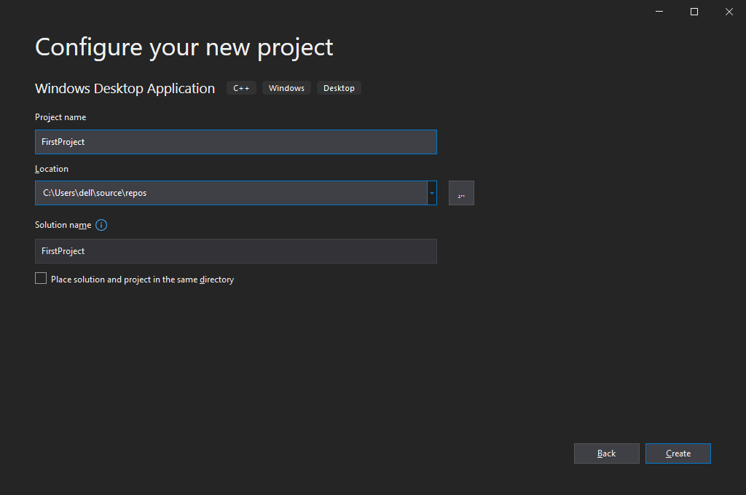

Then this solution has one project in it.

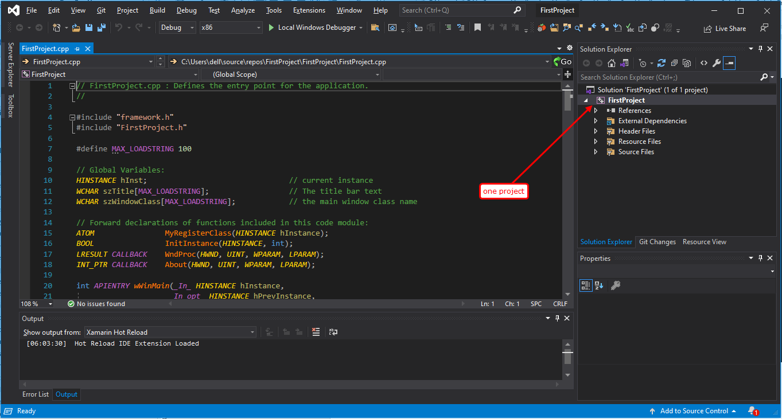

You can create a second project in this solution.

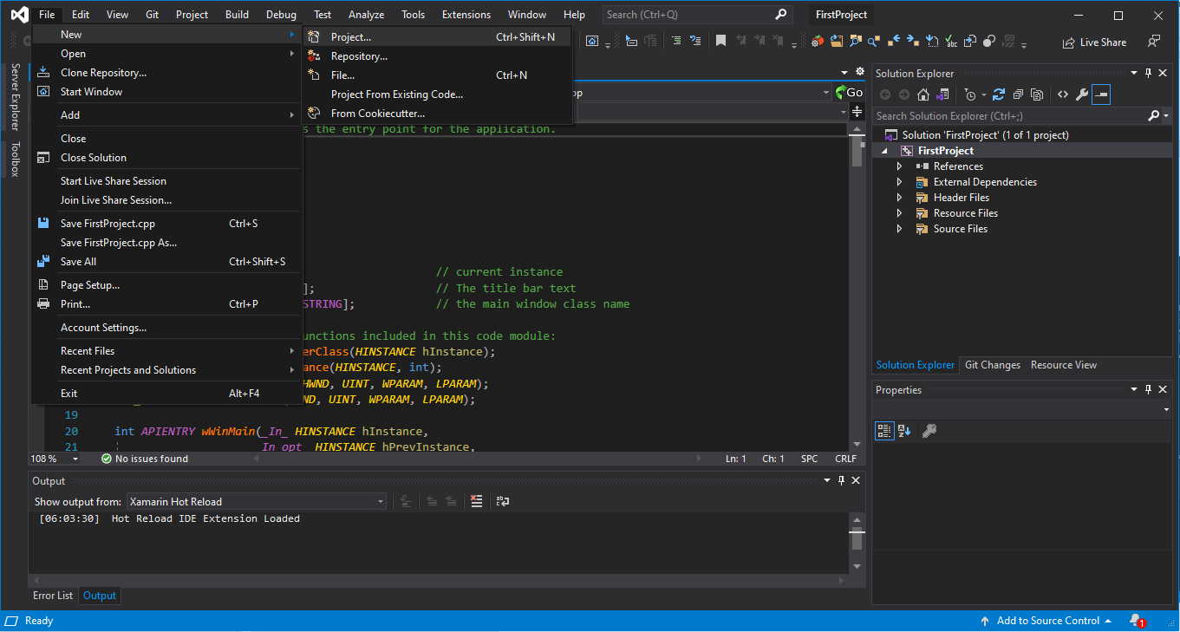

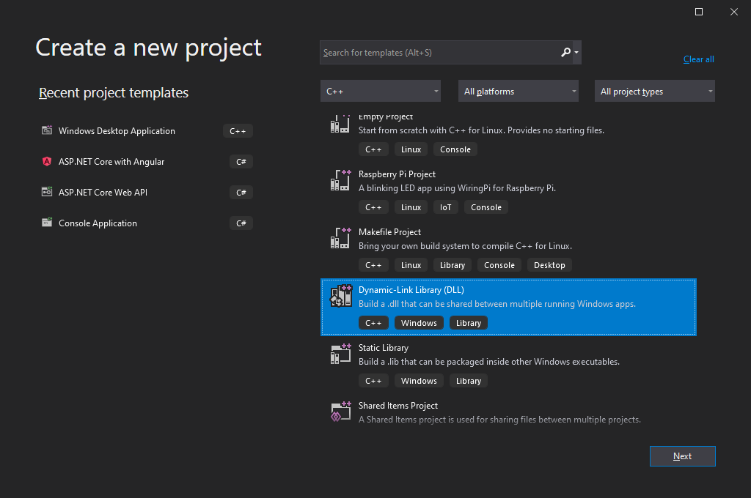

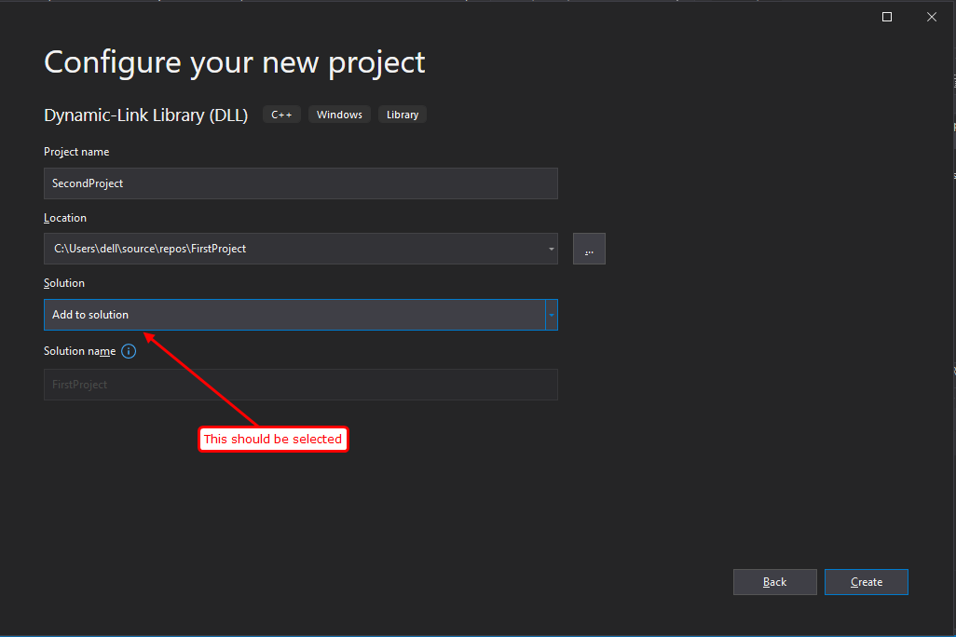

Don’t forget to set the selection to “Add to solution”.

Now you can see two projects in a solution.

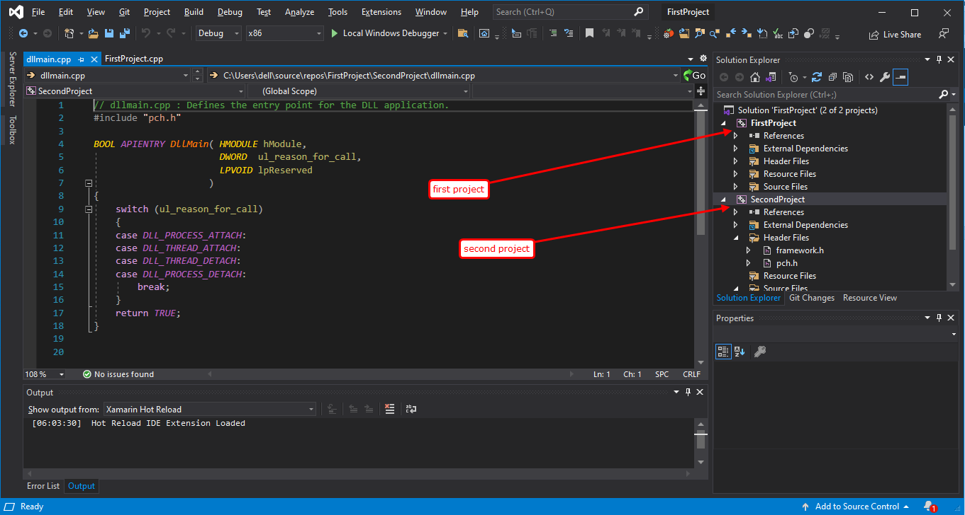

Two projects are located in explorer like

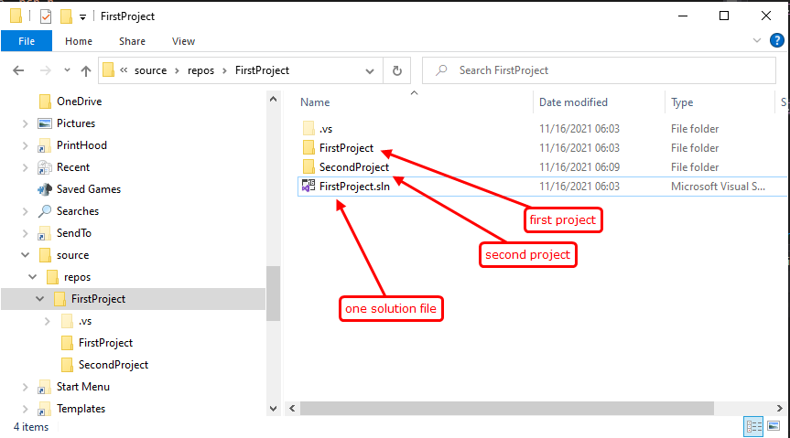

### How to build and run an individual project

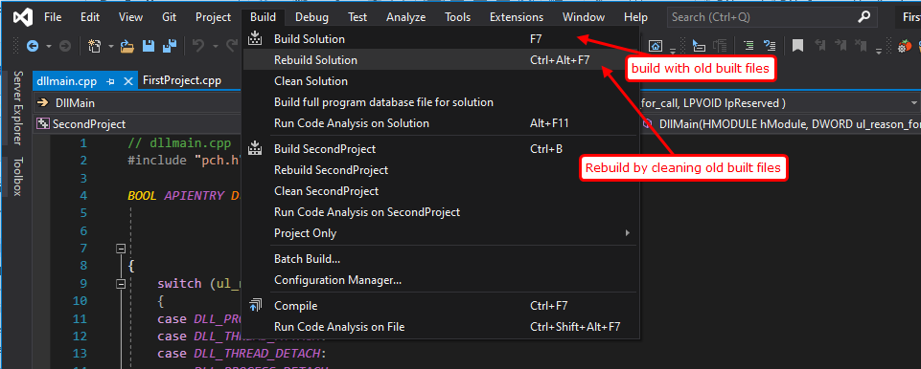

As you can see the picture above, you may press F7 key or “Ctrl + Alt + F7” key to built or rebuild project.

This will build all the projects in a solution.

To run the project, you should select the project to run.

It is called “active” project or “startup” project.

If you want to run second project, please select second project as “active”.

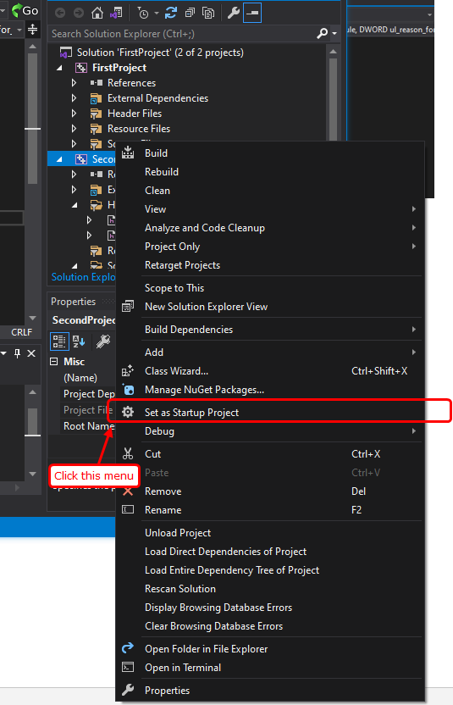

### How to change the build mode

By standards, Visual Studio has 2 modes for windows application. “Debug” and “Release”.

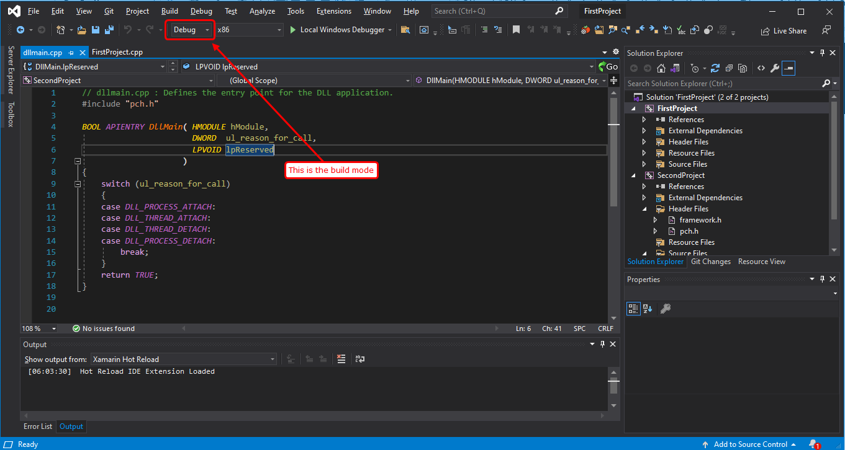

You can change the build mode by this dropdown list.

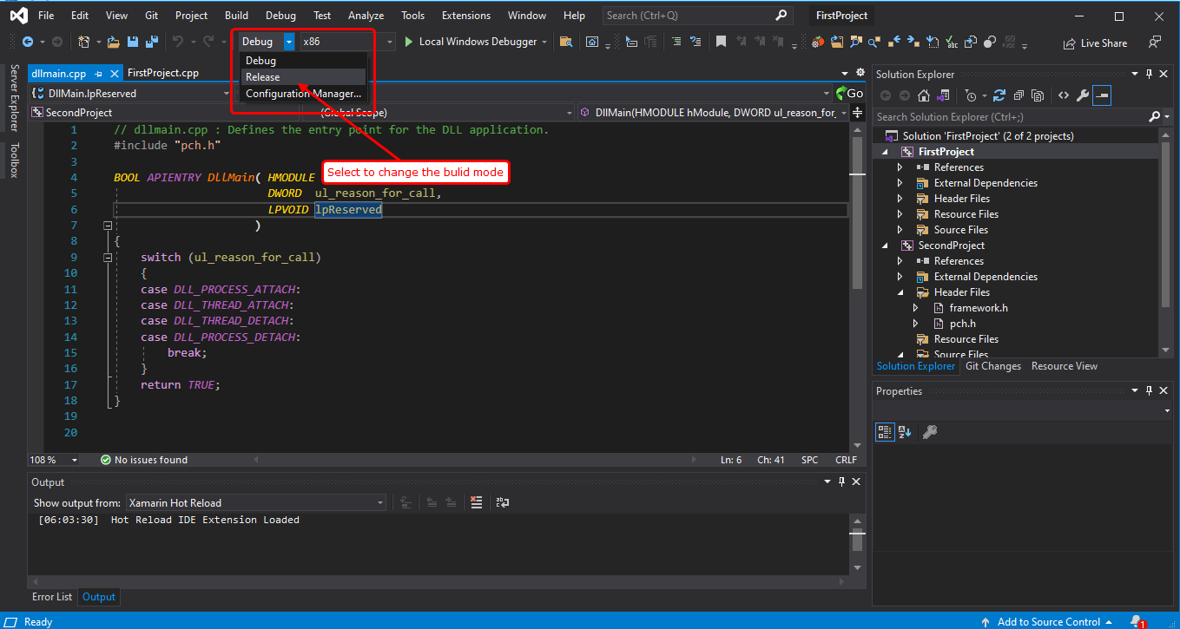

Or you can change build mode by the Build menu.

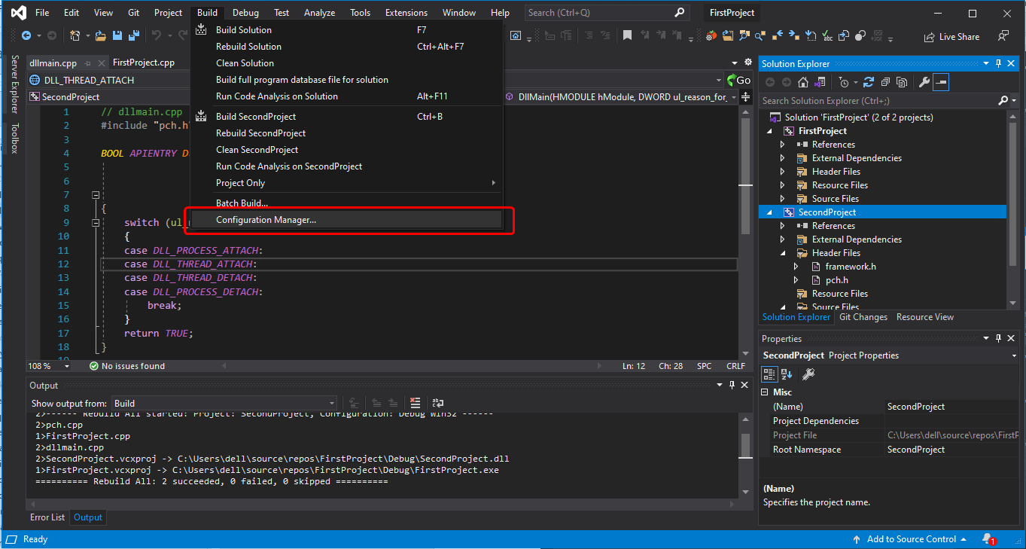

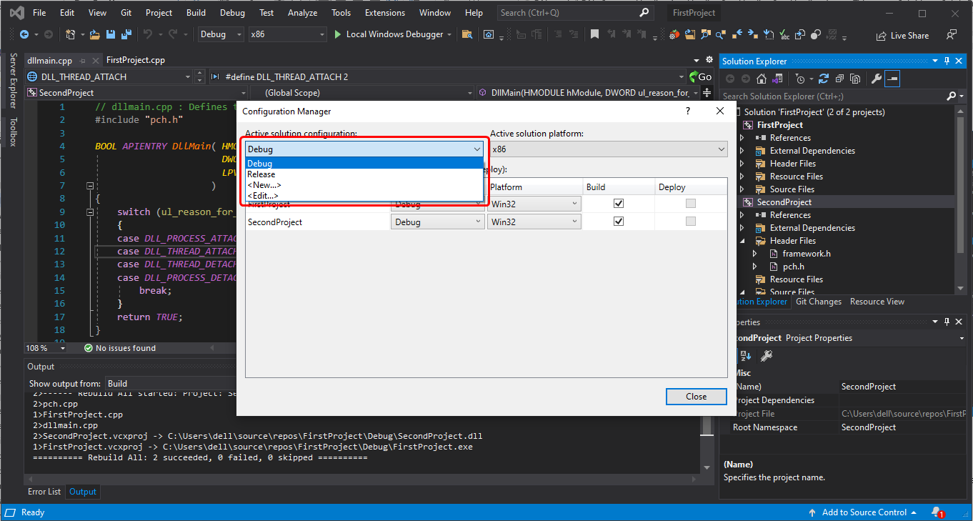

### What could change by build modes

Debug and Release modes build the project and make cpp application in “Debug” or “Release” folder.

But the size of the application varies to the build mode.

In Debug mode, Visual Studio adds some debug information to output application, such as function names, variable names, calling structures, command line numbers..

Furthermore, debug mode will make cpp app more analytic but it will cause its application speed slower.

In Release mode, Visual Studio does not add any debug information to output application.

Release mode makes output application less analytic and more optimized so that Release-built application runs faster than Debug-built application.

|  |  |  |
| --- | --- | --- |
|  | Debug | Release |
| Size | Bigger | Smaller |
| Speed | Slower | Faster |
| analytic | enough | Hard |
| Use | Developing | Product |

So while developing application, we usually use Debug mode because we need to debug and see the full information about errors.

But to make a product, we build in Release mode because it will run faster and less crackable to hackers because of its less analytic structure and information.

### Setting dependencies for the project

When you have multiple projects in a solution, you can build project in a specified order.

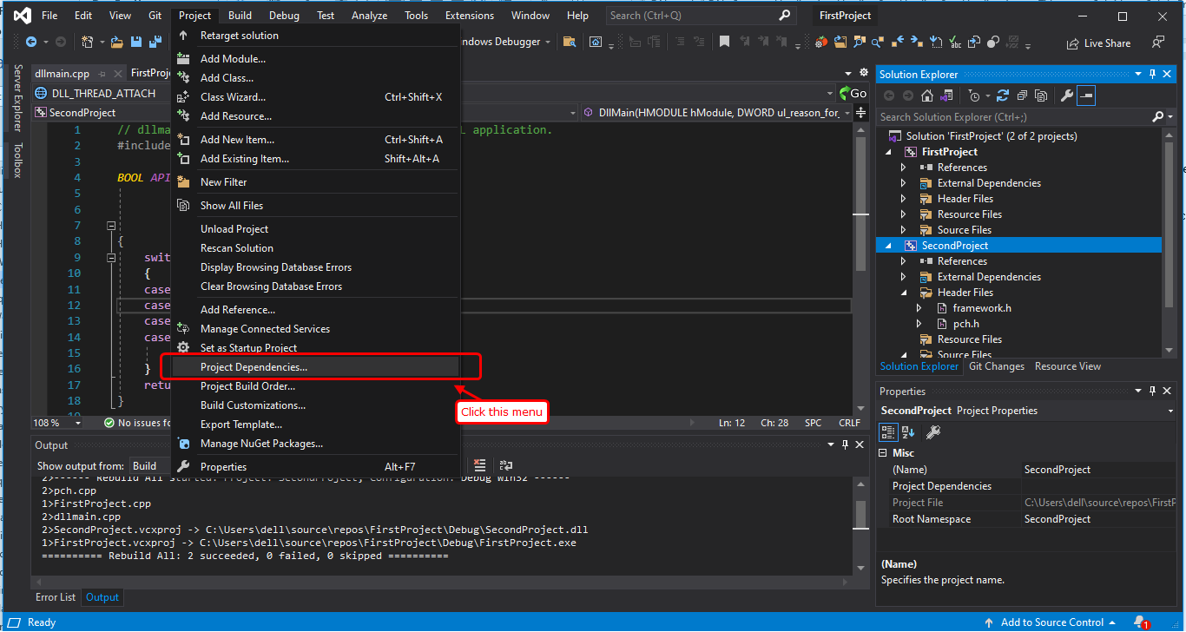

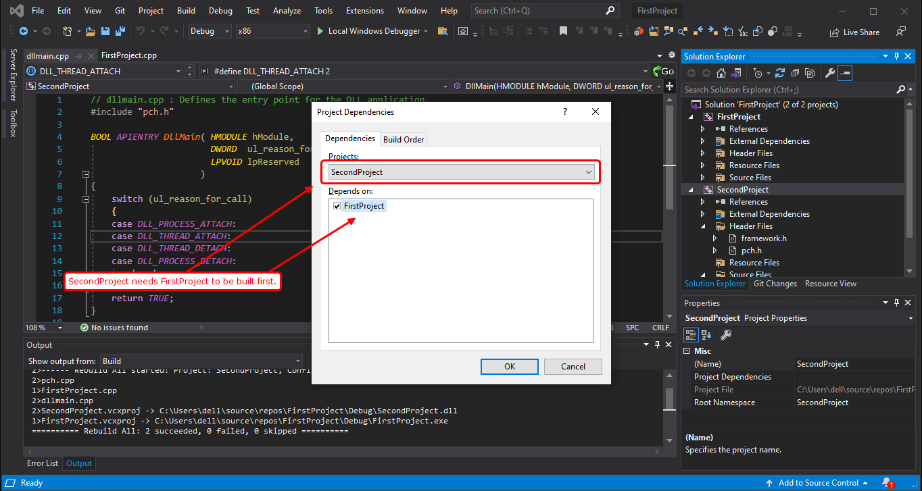

FirstProject is the one of the dependencies of SecondProject.

Because you set “SecondProject” as startup project, when you build SecondProject, FirstProject is built first and then SecondProject is built.

This is used when FirstProject is a library-project and SecondProject uses the library.

If no dependency is set to projects, multiple projects are built by order.

If dependency is set to projects, then Visual Studio reorders to build by the dependency of all the projects.

## Sqlite library with encryption

First, extract the source project in some directory.

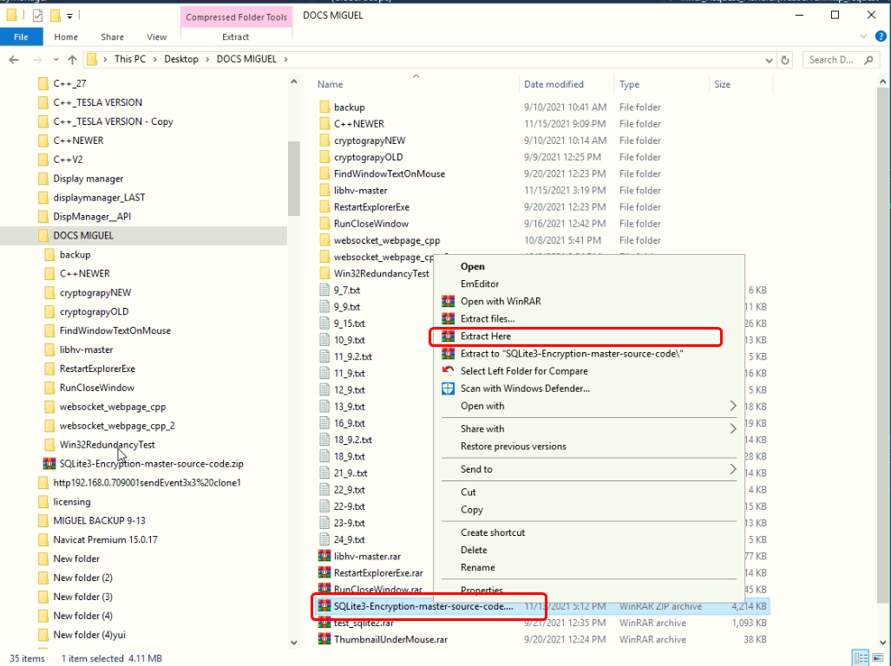

Run cmd console.

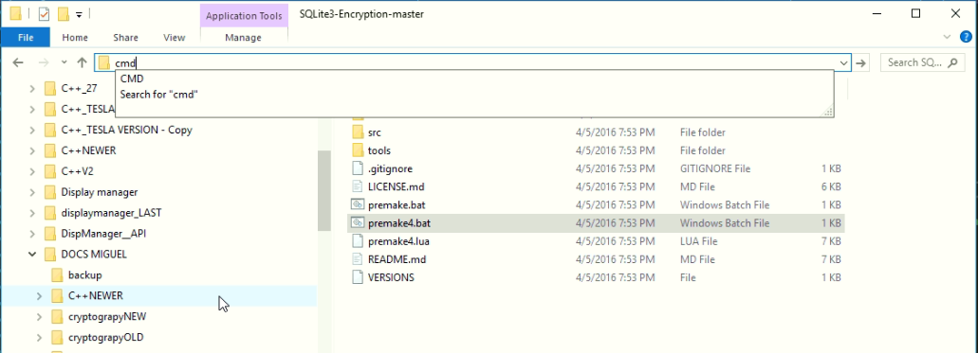

And then please run premake4.bat.

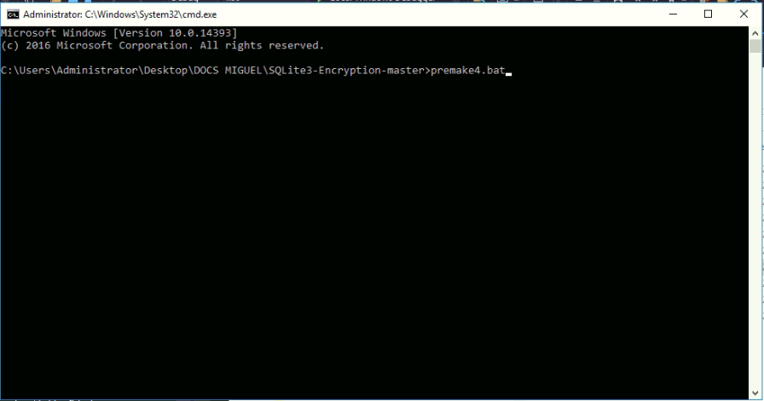

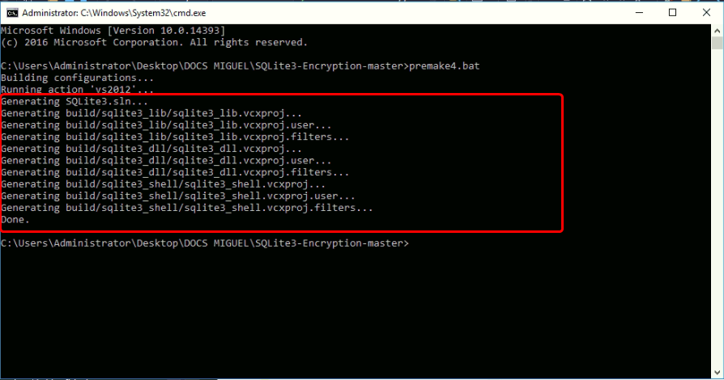

One solution file and several project files are generated.

Double-click to open a visual studio solution.

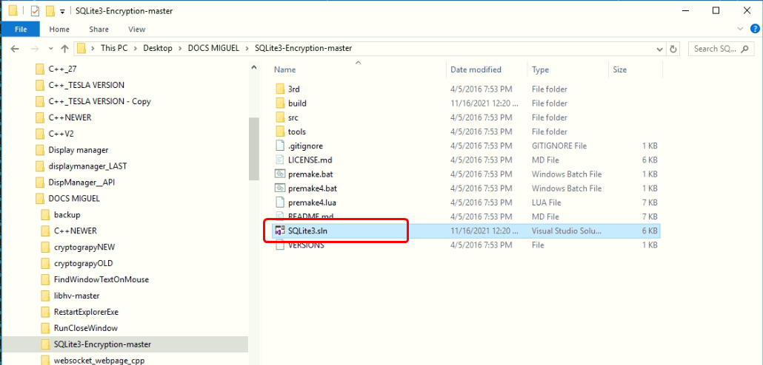

Convert the projects into the current Visual Studio version.

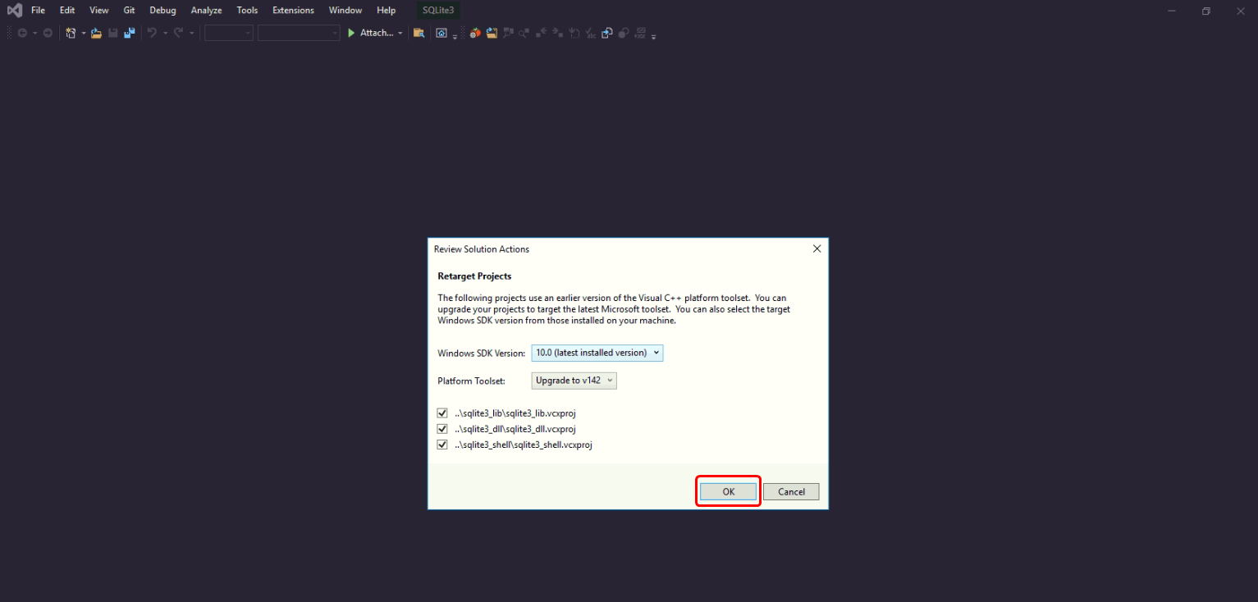

To build all the projects in a solution, Run the menu Build

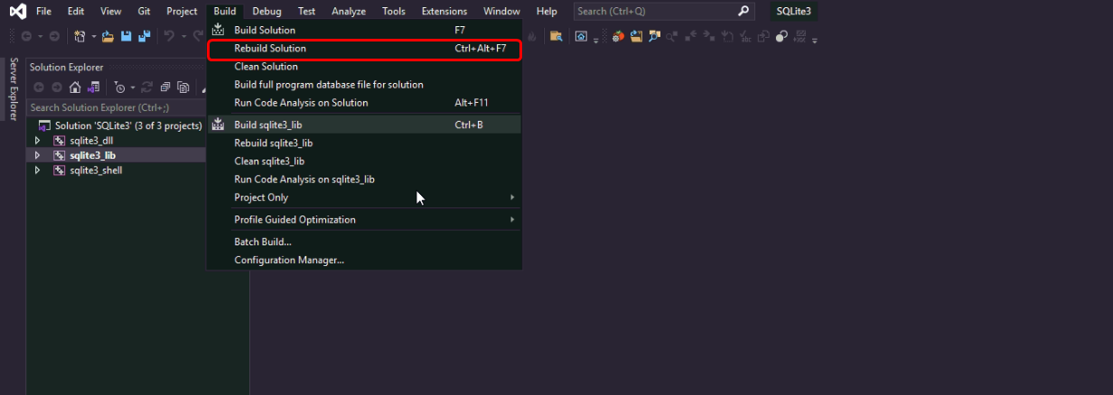

To get faster running library, please change build mode to “Release”.

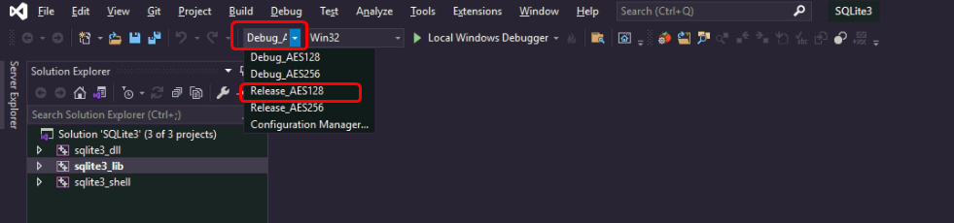

We choose “Release_AES128”. Please remember “Release_AES128”. AES128 is the encryption algorithm for sqlite db files with passwords.

Later when you make an sqlite db file, you should open it by AES128 encryption method.

After rebuilding the projects, you can see the library files generated in the project folder.

To use this library in your cpp application, you have to copy header file(sqlite3.h) and library file(sqlite3.lib).

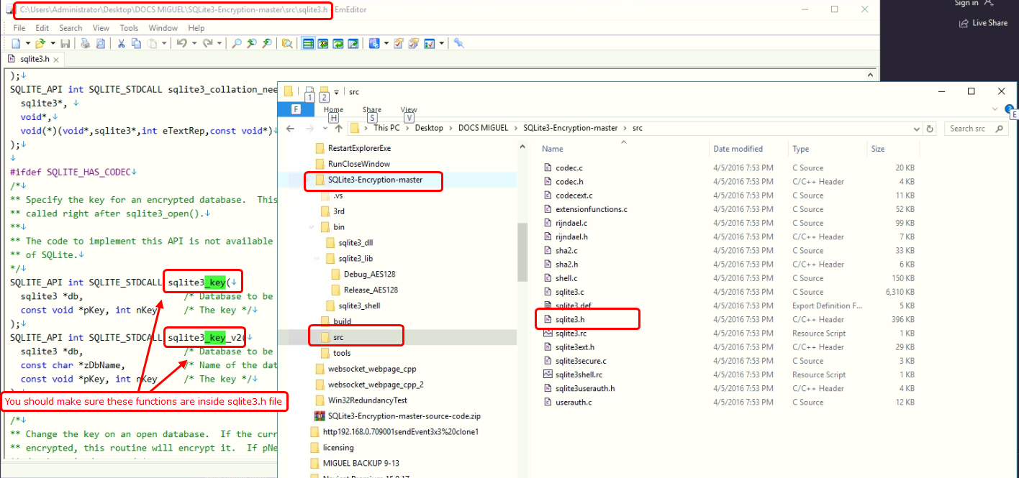

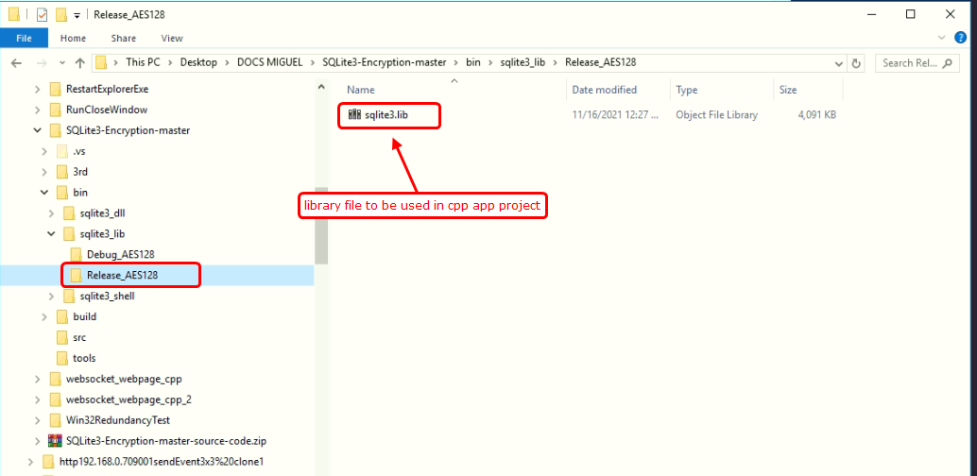

These two files are copied in the cpp project directory folder.

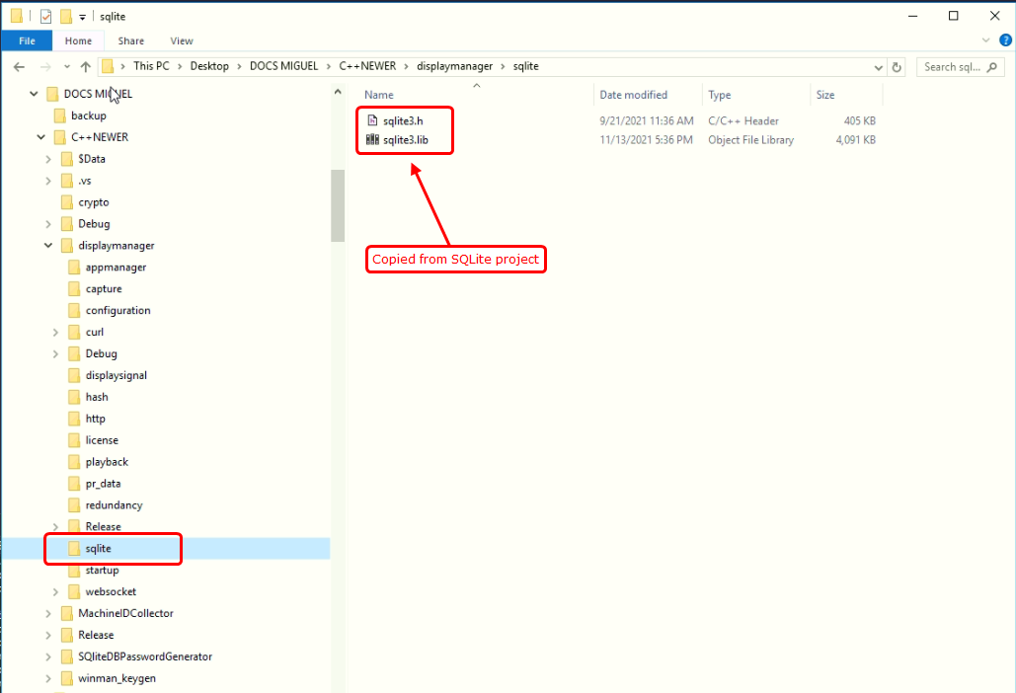

## Websocket library

First our websocket library is an open-source project(libhv-master.rar).

Extract source code in some directory. Here we named “libhv-master-new”.

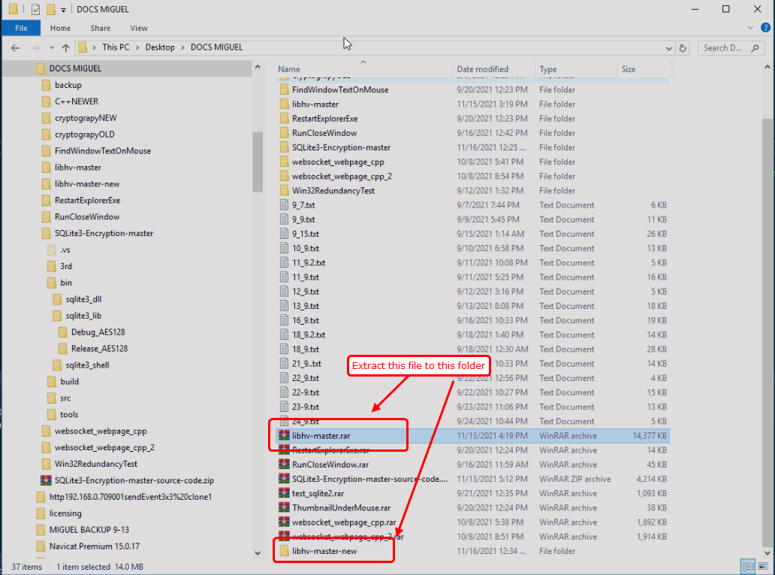

This project is not a normal Visual Studio project. It is called CMake project.

To built this project, you use CMake tool.

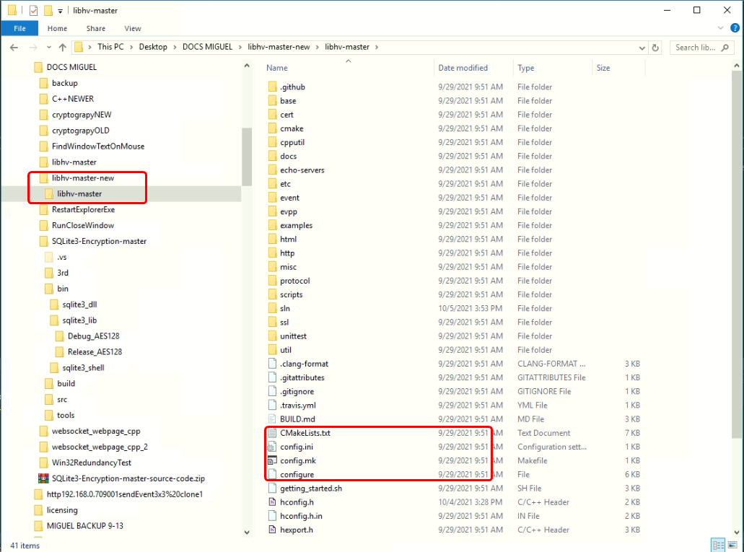

There is no solution file in the folder.

CMake tool will configure all for Visual Studio.

First run CMake tool.

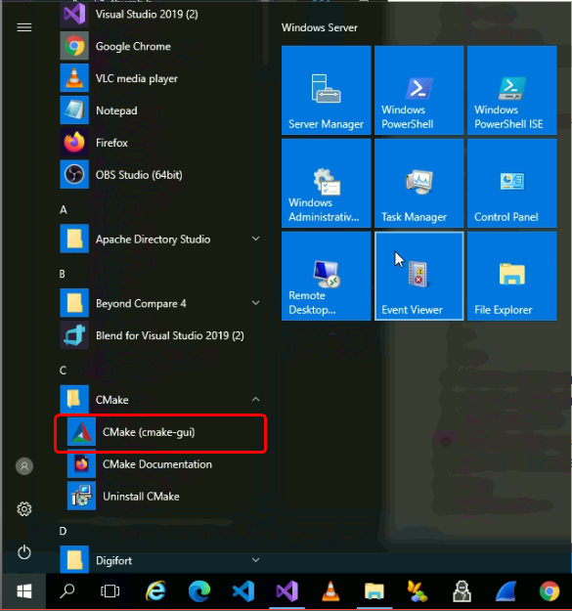

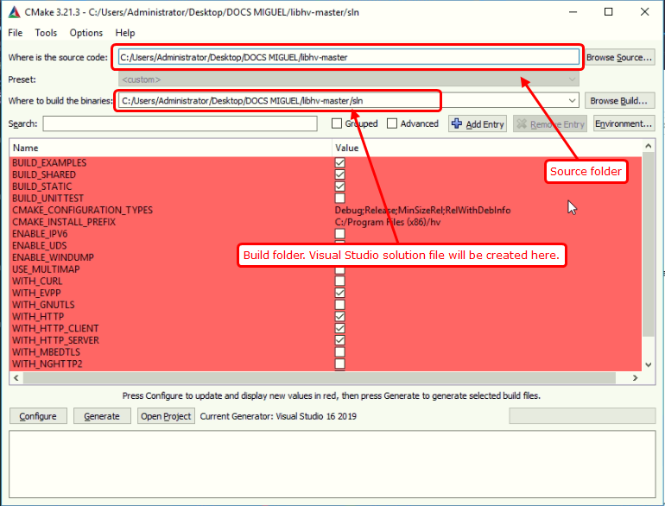

Input the CMake project folder to Souce code text box.

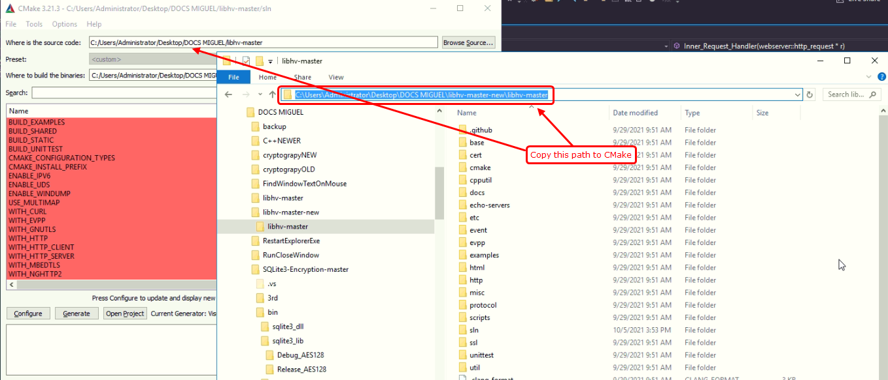

You can make build folder by inputting some directory. But here we use “sln” subdirectory in the project folder.

“sln” is not existing but will be created.

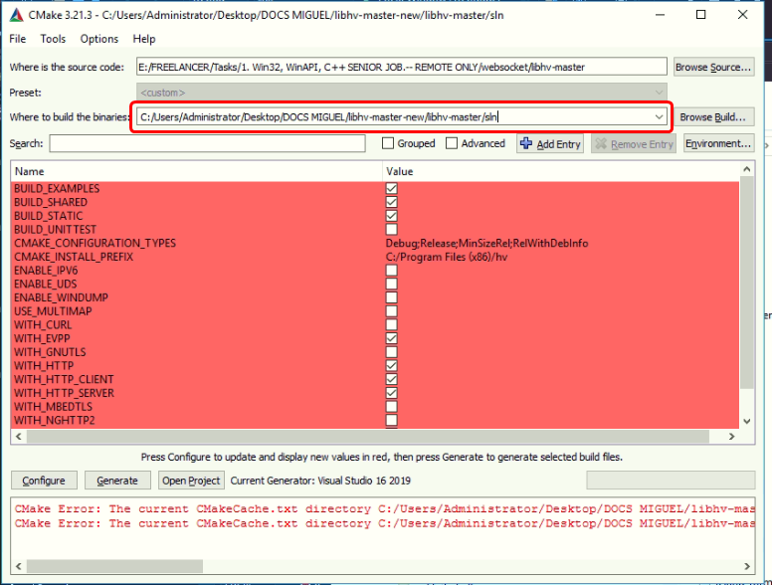

Press the buttons “Configure”, “Generate”, “Open Project” in order.

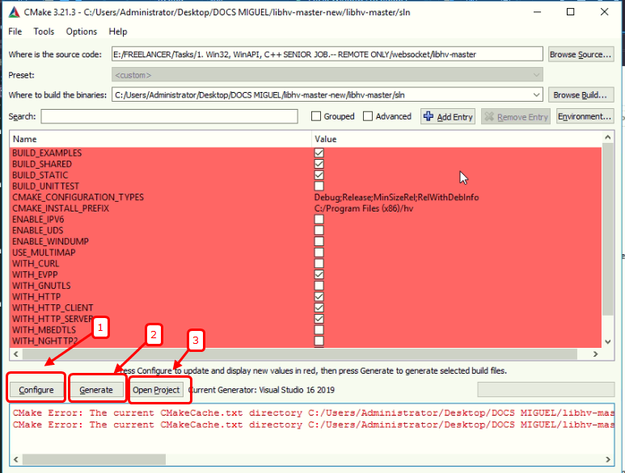

When you press configure button, it will show

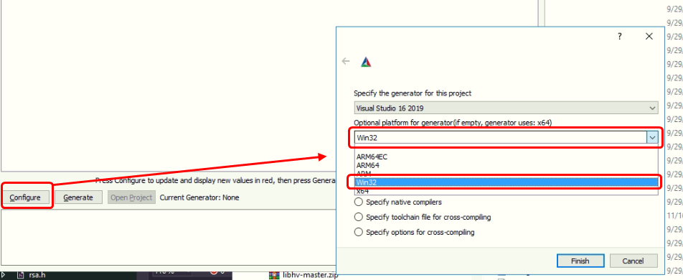

And press “Finish”.

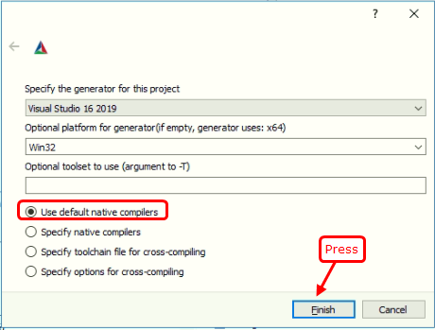

You should check the “sln” directory is created.

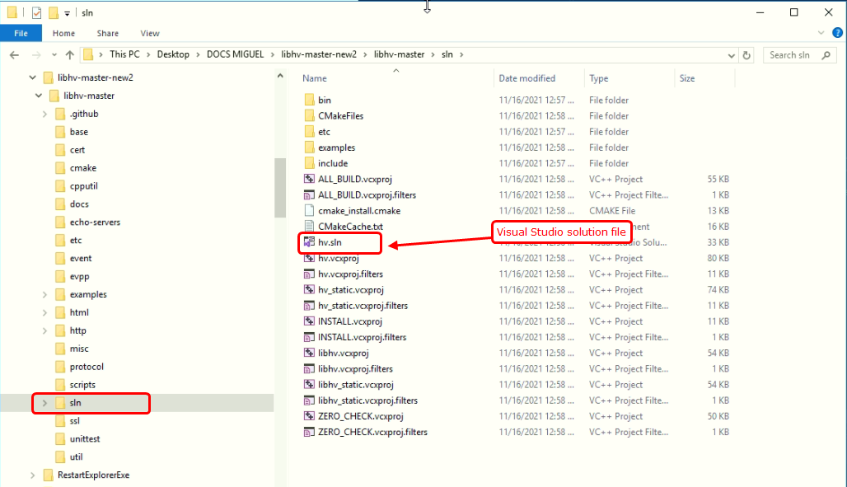

You can open project by double-clicking hv.sln file.

At first, you build the project by setting “ALL_BUILD” project as “startup” project.

You can build this project in Debug and Release mode.

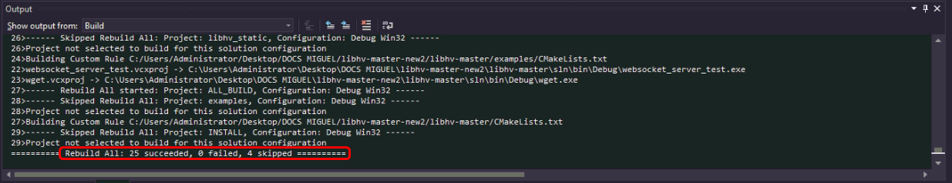

It is good with no errors while building.

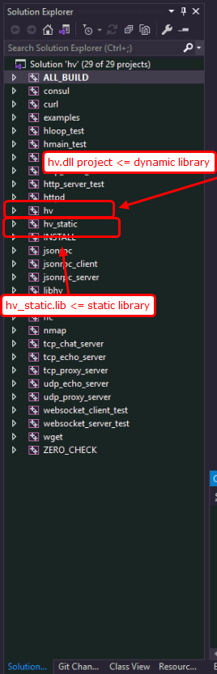You can see the multiple projects in a solution. But the main projects under our consideration are two projects, hv and hv_static.

“hv” project will make hv.dll and hv.lib files and those will be linked to our cpp app project.

If we use this dynamic library, websocket core features run in hv.dll so cpp app does not have websocket code. Cpp app only links whenever websocket code is need while running.

“hv_static” project will make hv_static.lib file and it will be linked to our cpp app project.

If we use this static library, websocket core features will be embedded into cpp app executive so that cpp app will run websocket code in itself.

So If developer directs more security against cracking, static library is highly recommended.

“hv.dll” file is generated in “sln/bin/Debug” or “sln/bin/Release” folder.

“hv.lib” and “hv_static.lib” files are generated in “sln/lib/Debug” or “sln/lib/Release” folder.

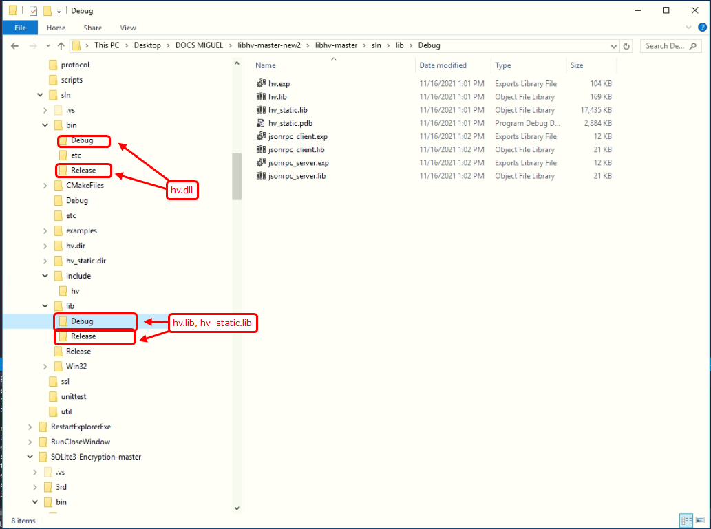

To use this websocket library in our cpp project, we need to copy some files into cpp project directory.

Header files(“sln/include”) and library files(“sln/lib”) are copied to the cpp project directory.

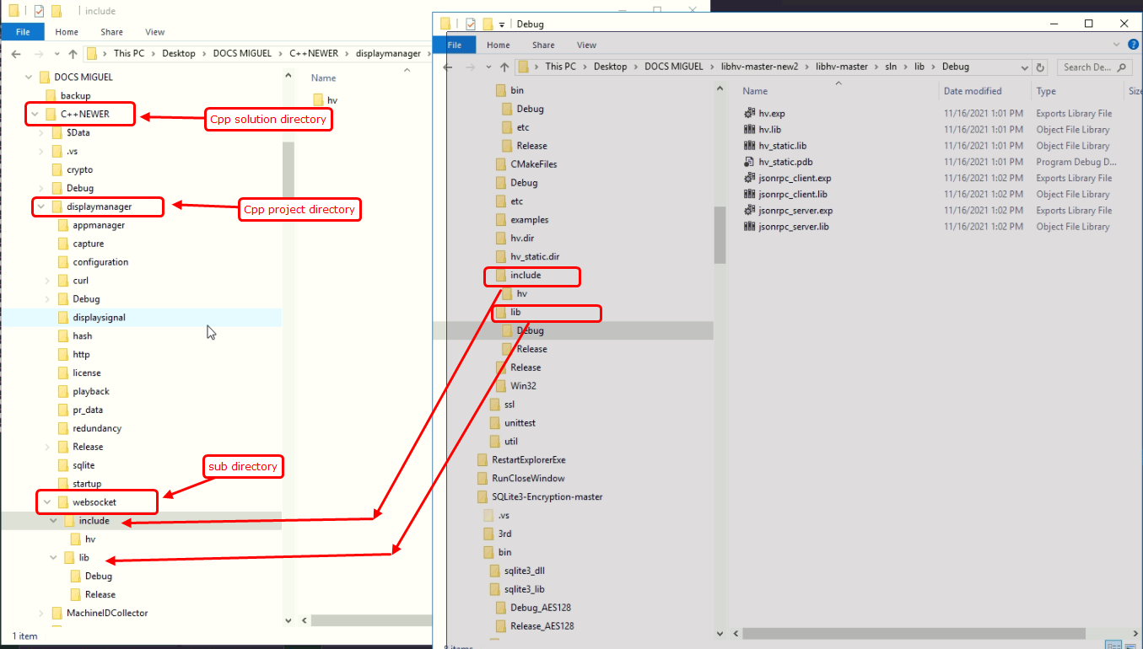

“hv.dll” in Debug and Release mode will be copied into the same directory as cpp application.

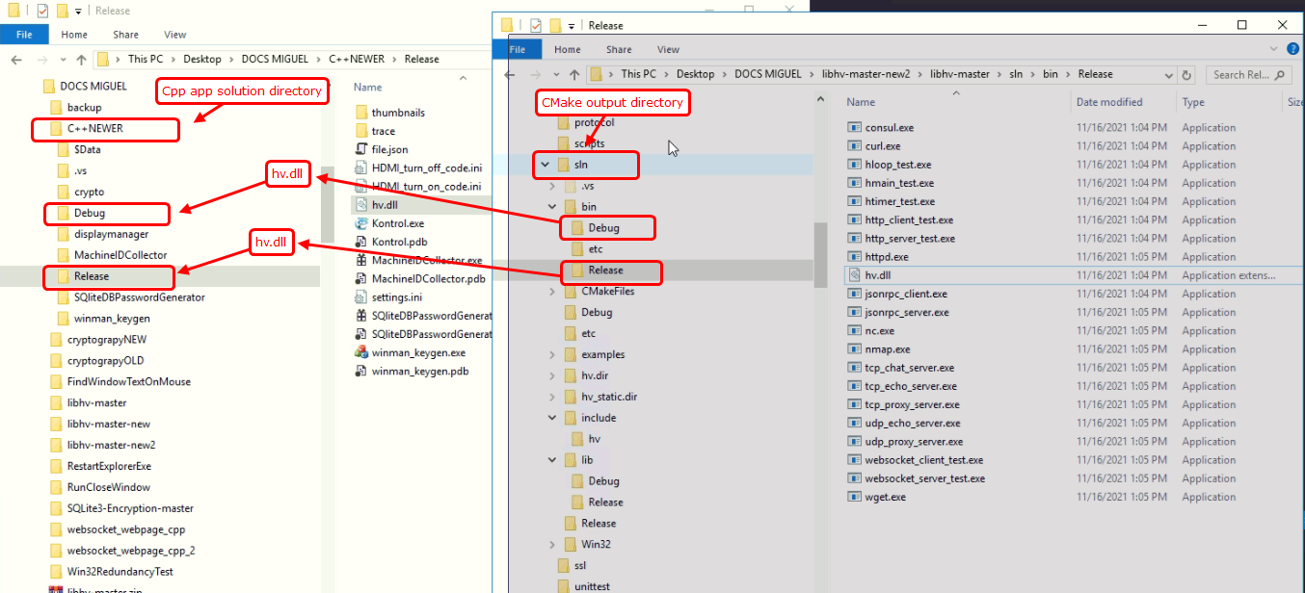

Header files are used for the prototypes of the functions to be used while compiling.

Library files are used for the linkage to the functions in a dll file while building.

Dll files are used as a websocket running module for cpp app at runtime.

# Configuration

## Settings.ini file

In the running directory of cpp application, you can see the file “settings.ini”.

This is the configuration file for running cpp app.

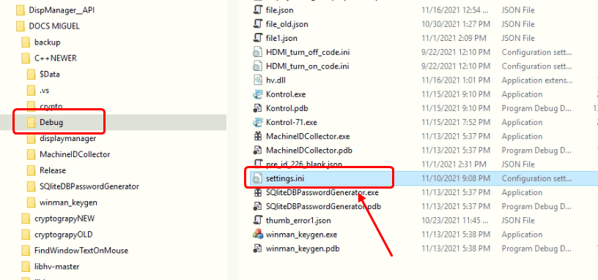

The content of this file has the several meanings.

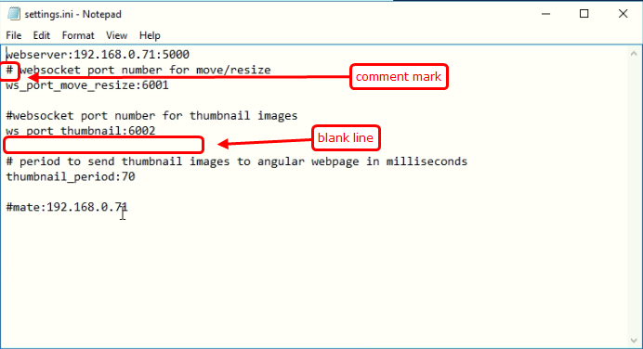

The first line is like

|  |
| --- |
| webserver:192.168.0.71:5000 |

The line which starts with “webserver” shows IP address for requesting presentation data. In this case, server IP is 192.168.0.71 and its port number is 5000.

The second line starts with a character ‘#’;

The lines which start with this character are considered comments, i.e. it is not used in cpp app.

So a user can add as many comment lines as he wants.

Third line is

|  |
| --- |
| ws_port_move_resize:6001 |

The line which starts with “ws_port_move_resize:” is considered as websocket server port for move/resize.

In this case, port number is 6001.

Fourth line is a blank line. (no characters, even ‘space’)

This line is not used. So we can use this blank line to well-looking configuration.

Sixth line is

|  |
| --- |
| ws_port_thumbnail:6002 |

The line which starts with “ws_port_thumbnail:” is considered as websocket server port for thumbnail.

In this case, port number is 6002.

Ninth line is

|  |
| --- |
| thumbnail_period:70 |

The line which starts with “thumbnail_period:” is considered as period in milliseconds of making thumbnail images.

In this case, thumbnail period is 70 milliseconds.

Cpp app makes thumbnail images every 70 milliseconds. If it takes more than 70 milliseconds to capture thumbnail images at a time, Cpp will make thumbnail images continuously.

The last line is

|  |
| --- |
| #mate:192.168.0.71 |

This line is commented. If we remove a character ‘#’ from this line, it will work for redundancy.

The line which starts with “mate:” is considered as IP address of mate computer for redundancy.

Let’s assume that 192.168.0.71 exists and cpp app runs at it.

If we run cpp app at this computer, it will work as a slave, so that it will not play any presentation.

When cpp app at 192.168.0.71 goes faulty, or crashes, or closed, then cpp app at this computer will be a master and play the same presentation as the last one at 192.168.0.71.

If 192.168.0.71 does not exist or no cpp app runs at it, cpp app at this computer runs as a master.

If this line is commented, no redundancy is enabled for cpp app so that it only runs as a master.

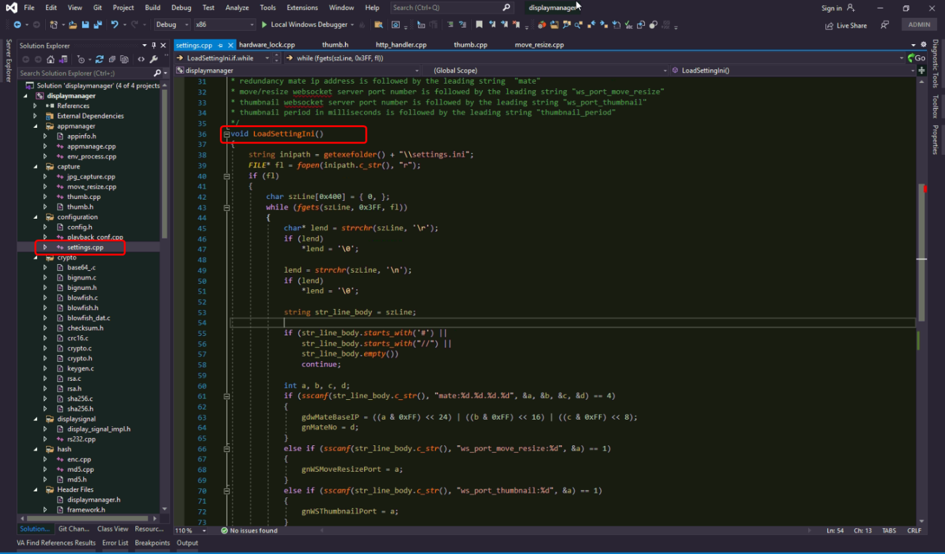

You will find the function “LoadSettingIni()”

### How to change the settings.ini file name or path.

You can find the following line in LoadSettingIni() function.



Here “inipath” variable represents the path of configuration file.

getexefolder() returns the folder path of cpp app.

“inipath” will point to the path of the settings.ini file located in the directory of cpp app.

You can change the path by changing “inipath” variable value.

### How to add comments in settings.ini file

Settings.ini file can have the comments by line.

As explained above, ‘#’ is the leading character of the comment line.

In LoadSettingIni() function, you can see the code like this.

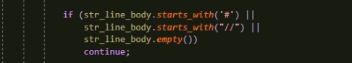

As you can see here, comment line starts with a character ‘#’ or a string “//” like C comment lines.

But there is no way to comment sub-string in the line like C commenting /**/.

If you would like to add more symbols to represent comment lines, change the code above as you want.

## Registry

Cpp app uses registry items for saving the last playing context.

|  |
| --- |
| HKEY_CURRENT_USER\\SOFTWARE\\CireApp\\WinManager |

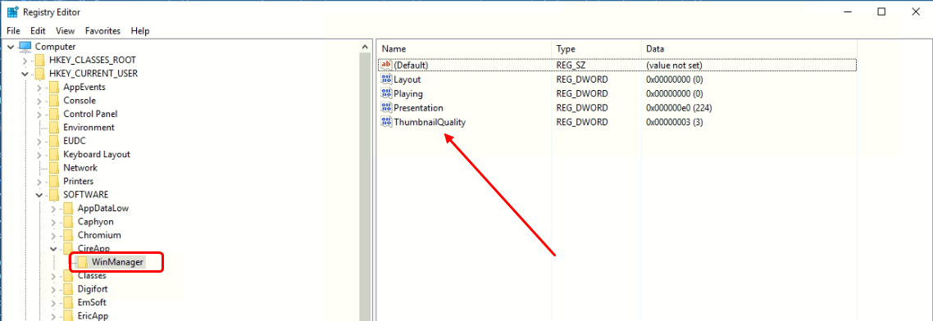

This key(it is called “Registry Key”) contains 4 values.

|  |  |
| --- | --- |
| Playing | Flag that represents the presentation was playing before closing app.  It is updated whenever you play a presentation, or stop presentation. |
| Presentation | Presentation id which is played by cpp app.  It is updated whenever you play a presentation. |
| Layout | Layout index which is played by cpp app.  It is updated whenever you play a presentation or going to the next layout automatically. |
| ThumbnailQuality | It is one of the following numbers.  1, 2, 3  It is updated when cpp app receives http command from webpage. |

### When is it loaded from registry?

Loading registry values are proceeded in GetLastLayout() function in “playback_conf.cpp”.

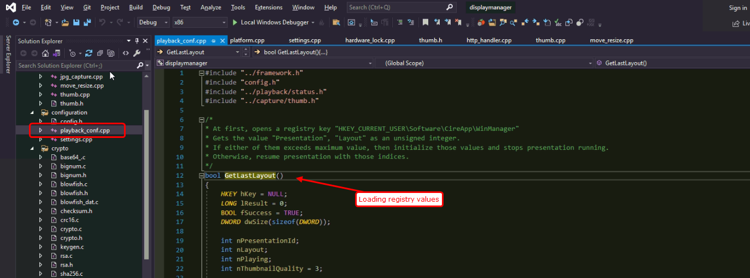

You select this function name and press “Shift + Alt + F” key.

Then you will see the result of references in the project.

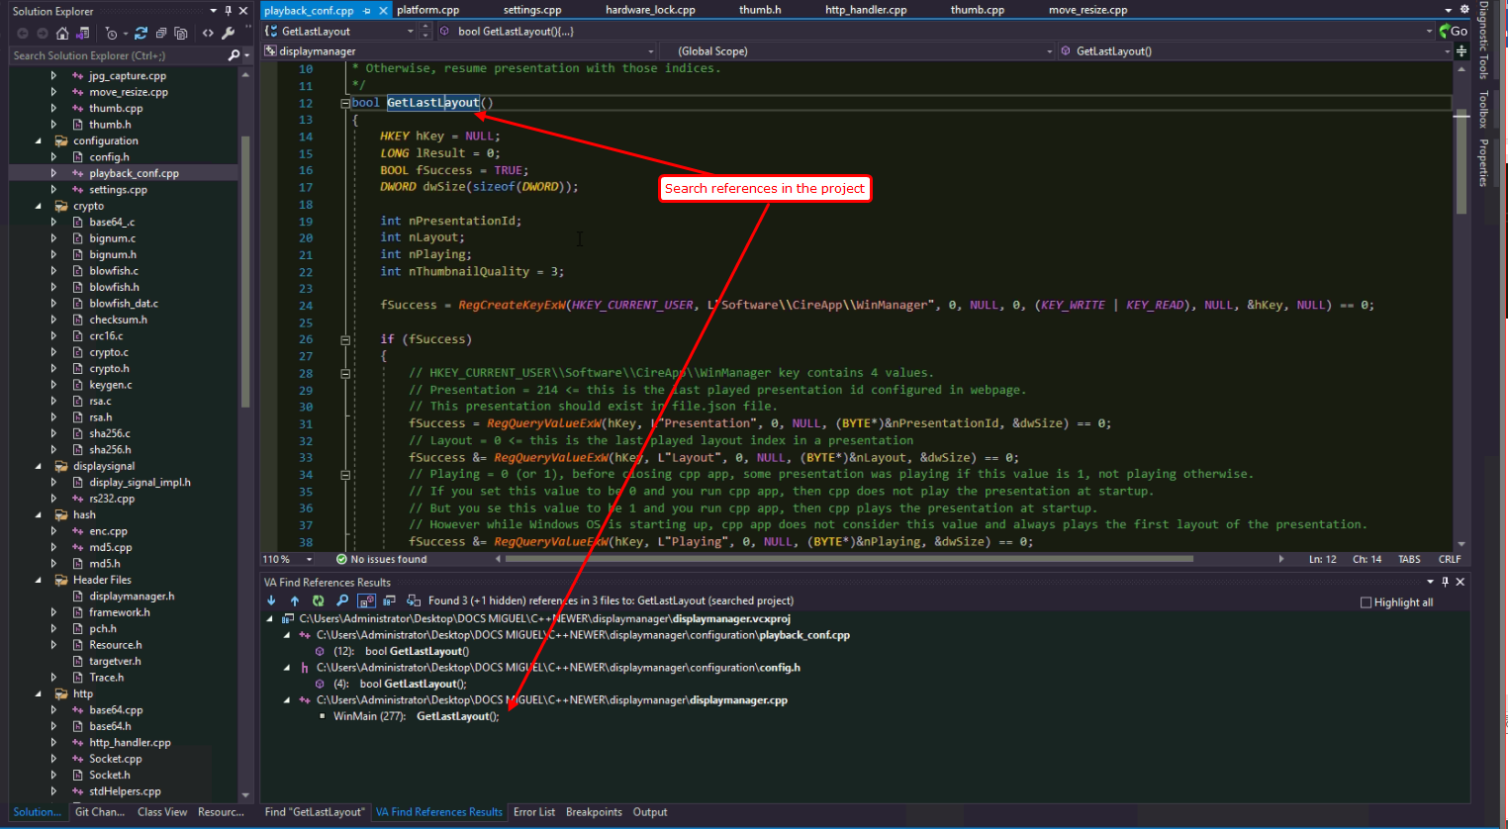

As you can see, WinMain() function calls this function.

It is called at startup of cpp application. It is called just once.

So we may change the registry value. If we run cpp app after changing, cpp app will read registry items.

Variables corresponding to registry values are as follows.

|  |  |  |  |
| --- | --- | --- | --- |
| Registry value | variable | Initial value | File name |
| Playing | BOOL presentationRunning | FALSE | main_process.cpp |
| Layout | int gnLayoutPlaying | 0 | main_process.cpp |
| Presentation | int gPresentationPlaying | 0 | main_process.cpp |
| ThumbnailQuality | int gnThumbImageQuality | 3 | thumb.cpp |

### When is it saved?

In playback_conf.cpp file, SetLastLayout() function saves the context of playing presentation.

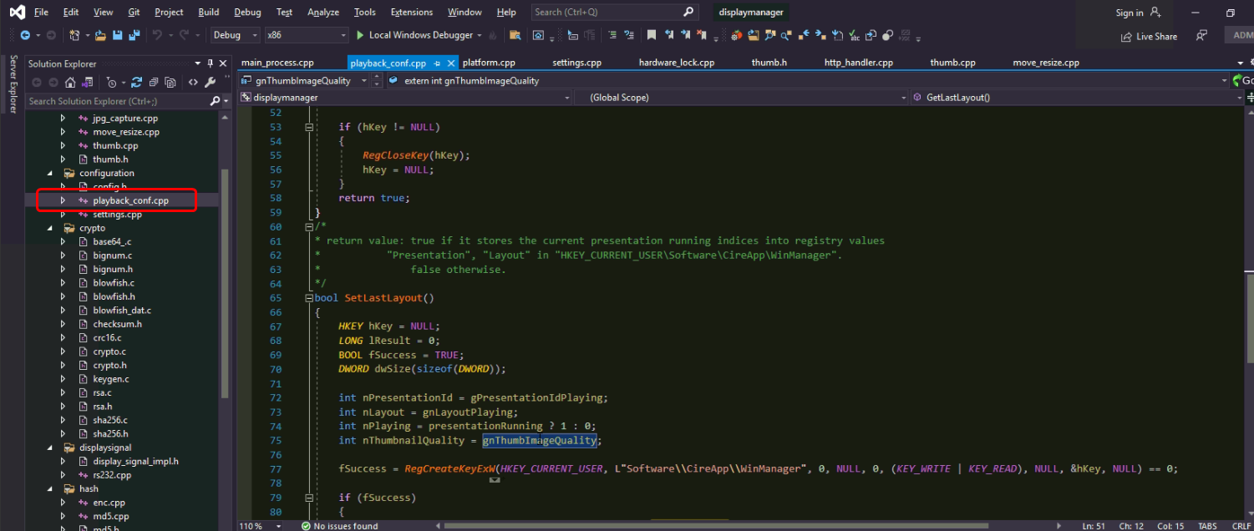

You select the function name in editor, and press “Shift + Alt + F” key.

The result is shown at the bottom of the window.

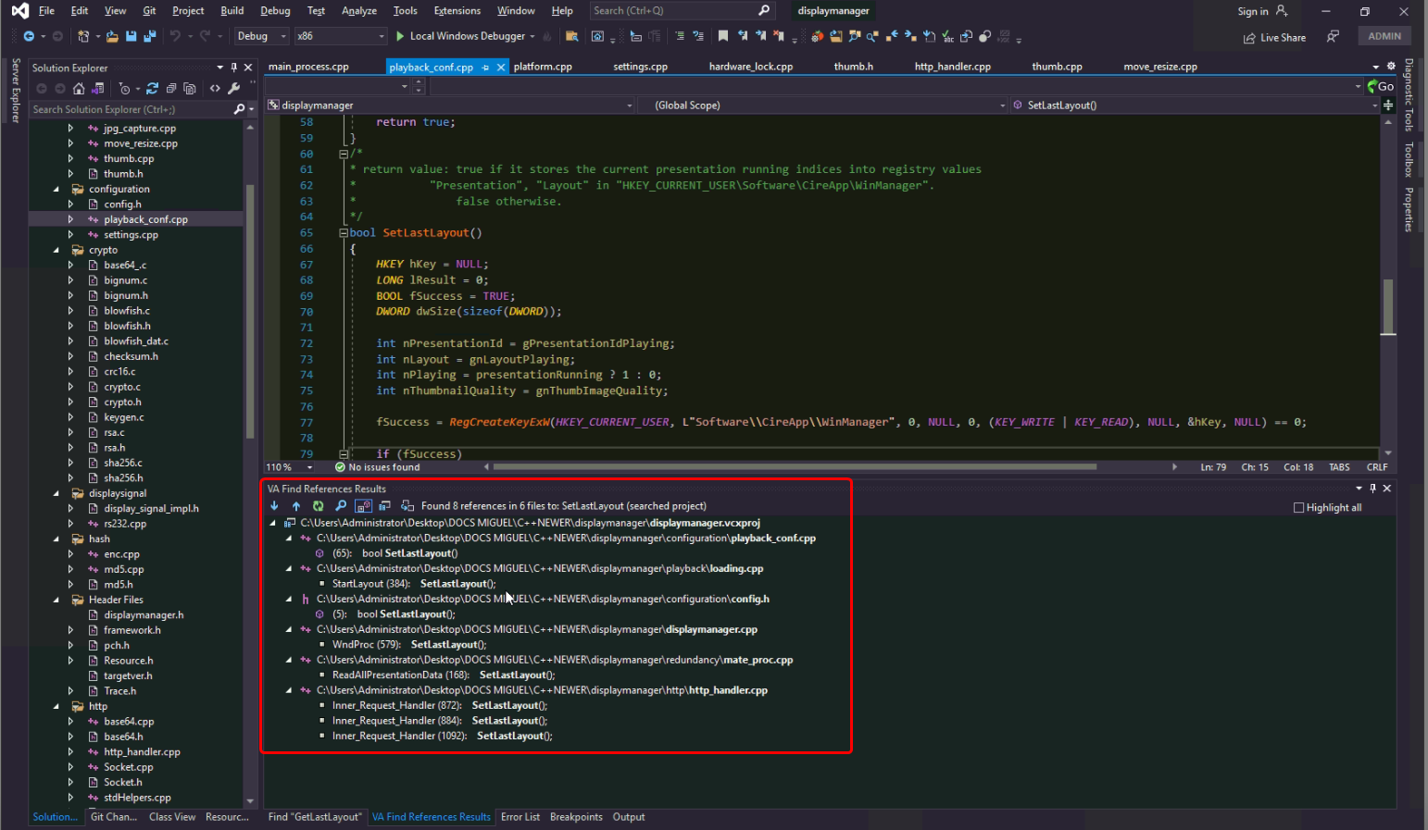

Calling this function are the following cases.

|  |  |  |
| --- | --- | --- |
| Function | File | Description |
| StartLayout | loading.cpp | When a user plays a presentation on webpage or  it automatically goes to the next layout or rewind. |
| WndProc | displaymanager.cpp | When the main window is closed. |
| ReadAllPresentationData | mate_proc.cpp | When cpp app runs as a slave and receives presentation data and context from its master(mate). |
| Inner_Request_Handler | http_handler.cpp | When a user presses “close-app” button on webpage.  When a user presses “shutdown” button on webpage.  When a user changes thumbnail quality on webpage. |

# Licensing

## Cryptography

We use cryptography for licensing.

Licensing will work as the following.

Computer automatically gets device id string from hardware information of local computer

Show

User

Request activation code

Keygen

Input device id string

Generate

activation code

Provide with activation code

input activation code

Valid

No

Yes

Play

Presentation

Provider

Keygen is private program of provider. It can make activation code for user’s device id string.

Keygen application(=>) uses CRC16, SHA256, RSA2048 encryption(private key), blowfish encode, base64 encode.

Cpp application(=>) verifies activation code by base64 decode, blowfish decode, RSA2048 decryption(public key), SHA256, CRC16.

For more information, please see “Kontrol Licensing Manual.pdf”.

## Hash

We use hash algorithms for two features.

|  |
| --- |
| Getting device id string(MD5) |
| Generating and verifying activation code.(SHA256) |

MD5 code is an open source.

It is located in “crypto” folder. md5.h, md5.cpp.

SHA256 code is also an open source which can be found in sha256.c and sha256.h in “crypto” folder.

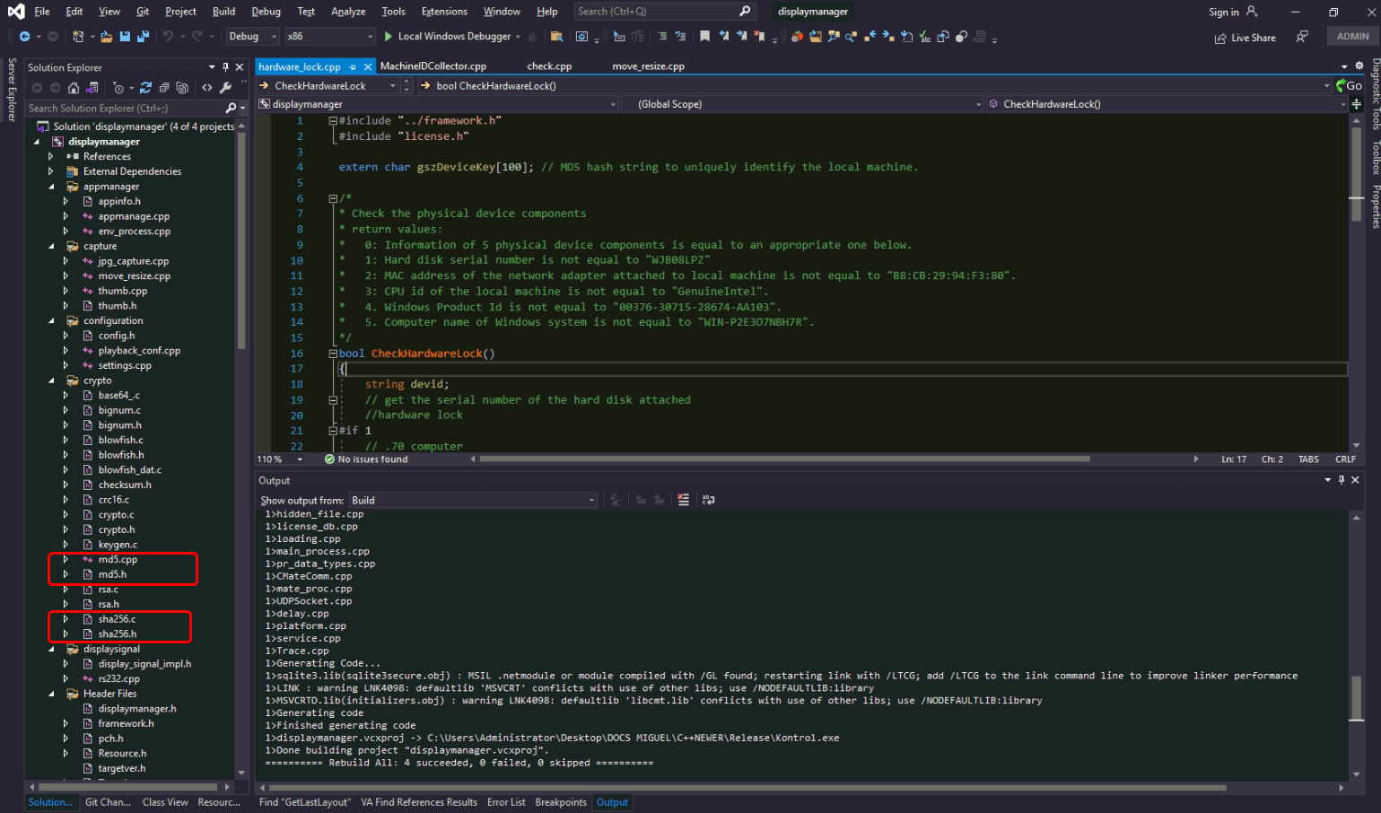

### How to change generation of device id string

In license folder, there is a file named “check.cpp”.

In this file, you can find GetDeviceHashString() function.

This function generates device id string by hard disk serial number, windows product id, mac address, Computer name, cpu id using MD5 hash algorithm.

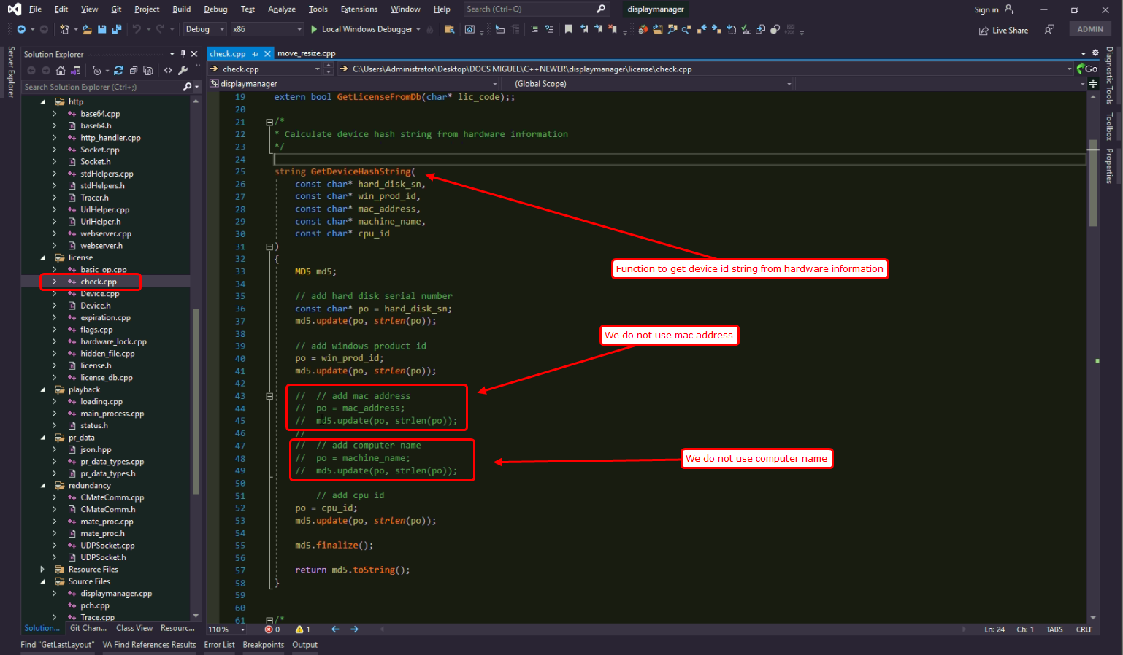

It has 5 parameters but we did not use mac address and computer name.

A user can change computer name on purpose and mac address can be changed if a user change his/her NIC.

So this function has 5 parameters but actually device id string is generated by 3 parameters.

If you want to enable/disable the parameter’s role, comment/uncomment the code lines corresponding to the parameter.

## Algorithm

For more information about licensing algorithm, please see “Kontrol Licensing Manual.pdf”.

## Activation code generation

A provider generates activation code for users.

When a user delivers his/her device id string to provider, the provider generates activation code.

In this section, let’s assume that you are a provider.

You can build “winman_keygen” project in a cpp app solution.

At first, please make winman_keygen be “startup” project.

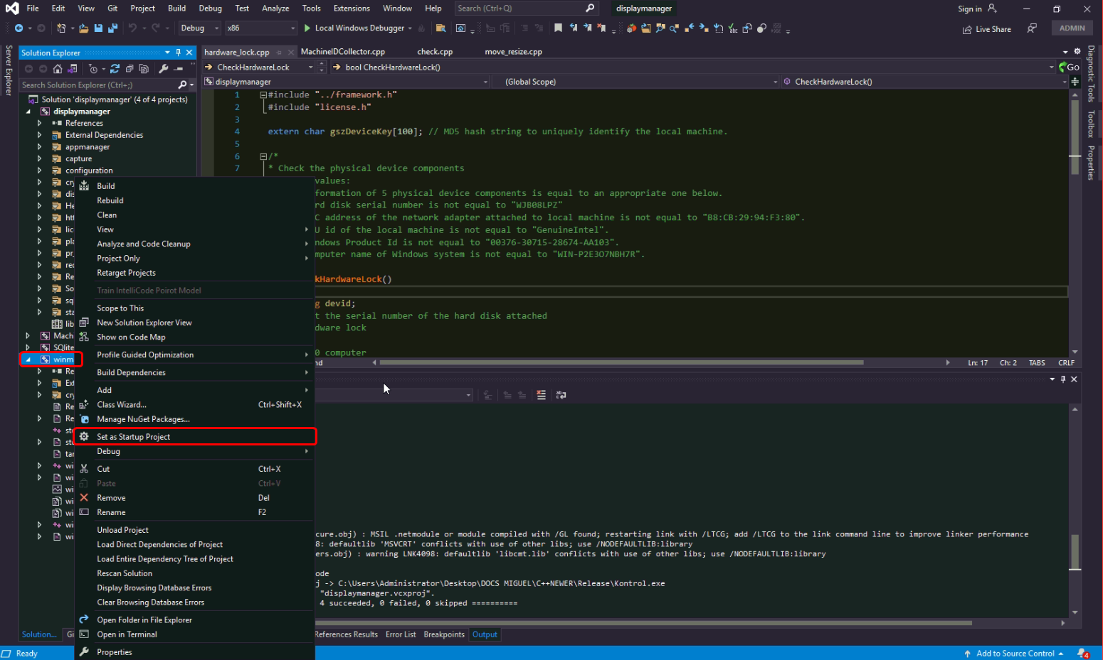

And press “F7” to build.

If you want to run in Visual Studio, press “F5” key or

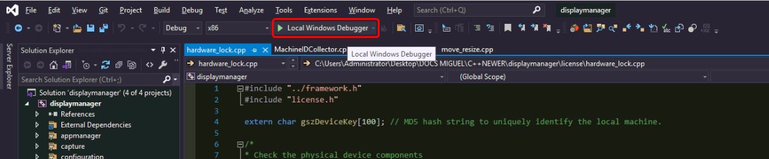

You will see the keygen app window.

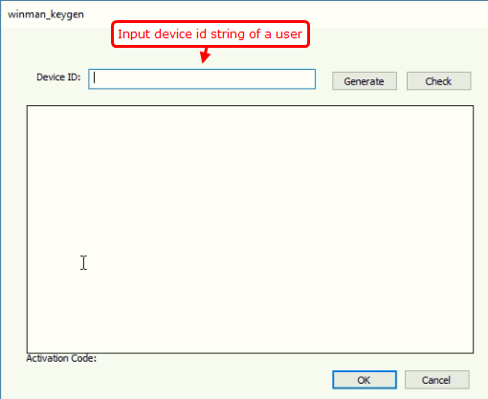

After input user’s device id string, when you click generate, activation code is generated.

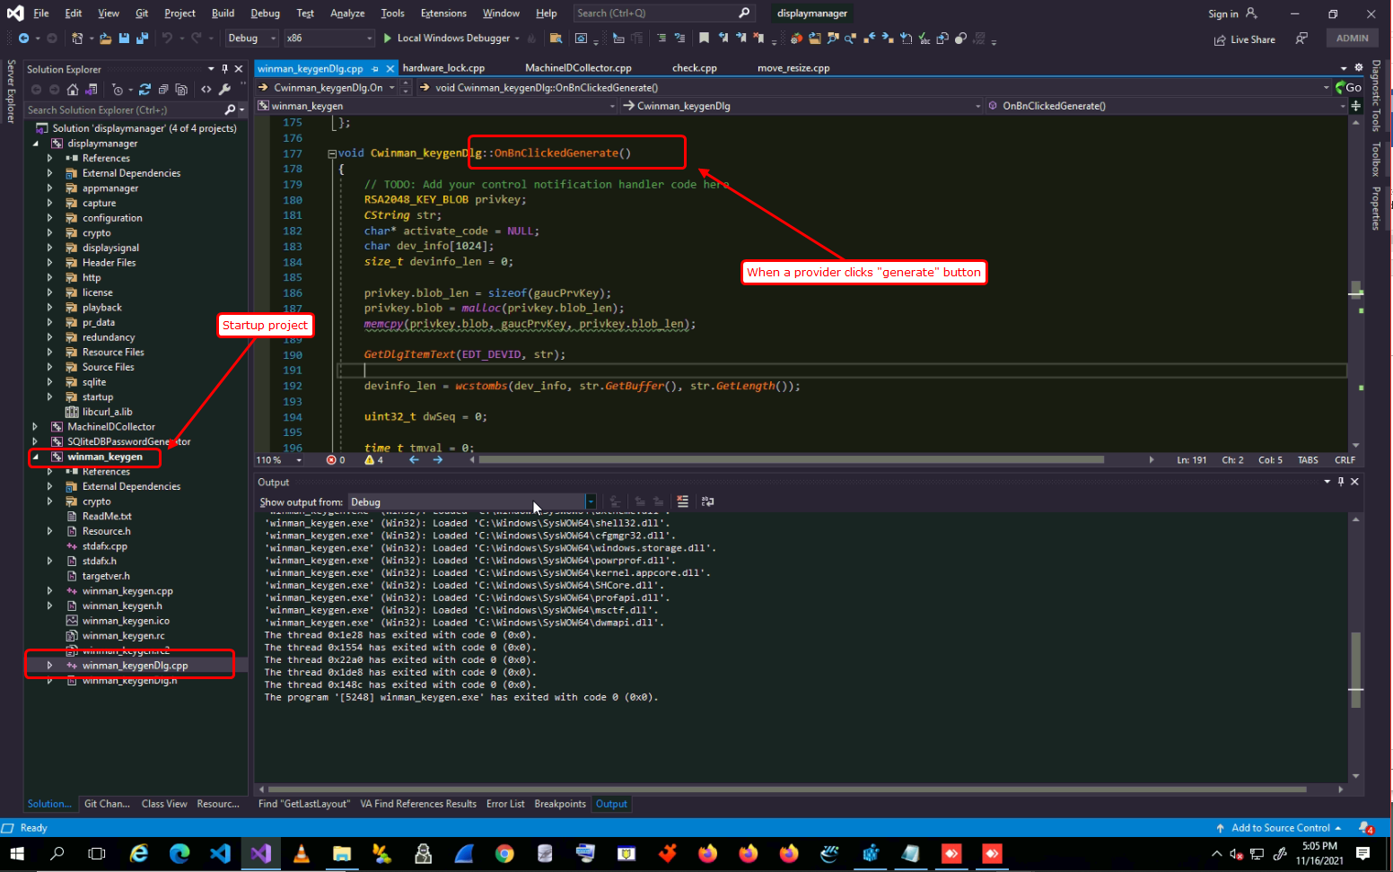

OnBnClickedGenerate() function will make activation code and shows it on dialog box.

### What is Keygen.info?

Activation code contains “sequence” which is the number that represents the unique id of activation number.

Whenever a provider generates an activation code, this sequence number incremented by one.

At initial, it is 0.

So the first activation code has sequence number 0.

And it will be 1.

The second activation code has sequence number 1.

And it will be 2.

…

If a provider closes keygen app, next time this sequence number should be kept and incremented by one whenever a provider generates activation code.

So sequence number should be saved permanently.

We implemented it by “kengen.info” file.

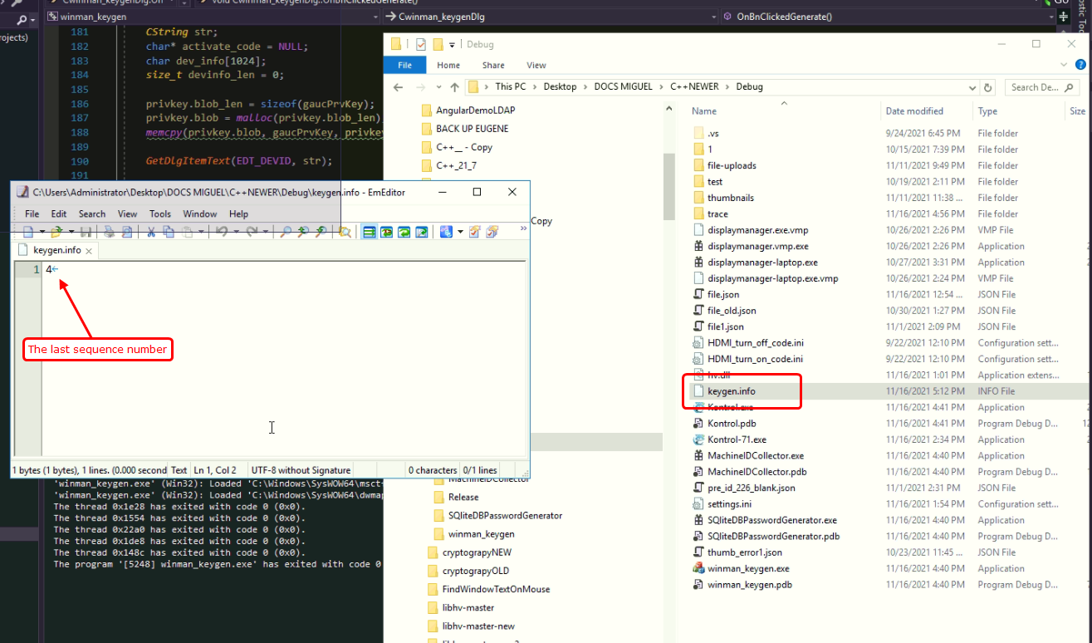

This “keygen.info” file saves the last sequence number.

When a provider runs keygen app and generate an activation code, keygen app reads the content of “keygen.info” file and increment it by one, generates activation code by the sequence number and save the new sequence number back to “keygen.info” file.

In a word, “keygen.info” saves the last sequence number of all published activation codes.

If you change the content of “keygen.info” file, for example “101”, then 102 will be the sequence number of next activation code and 102 will be saved in “keygen.info” file.

### How to change the trial period(expiration)?

OnBnClickedGenerate() function contains this part.

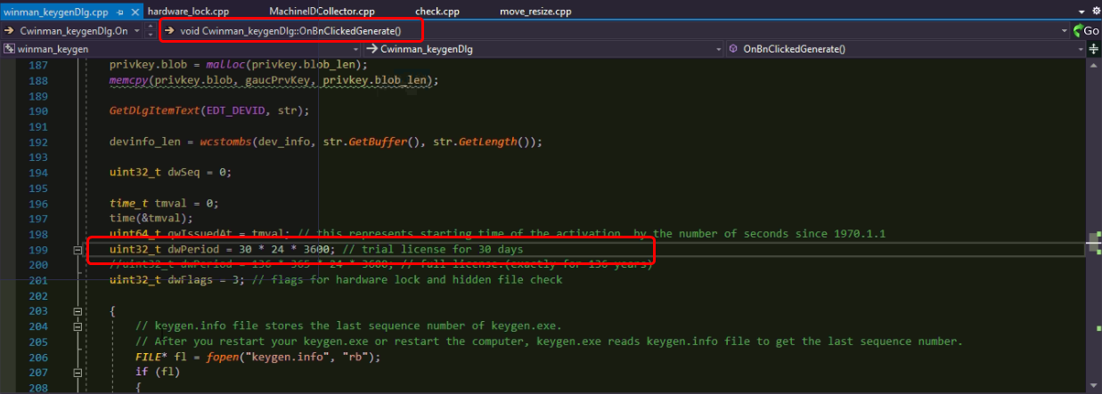

In this picture, dwPeriod is 30 * 24 * 3600 = 2592000. That is trial period is 2592000 seconds = 30 days.

If you want to change the trial period, please change dwPeriod value.

For example, the table below shows the case of “dwPeriod” variable.

|  |  |  |
| --- | --- | --- |
| C++ code | seconds | Description |
| dwPeriod = 3600 | 3600 | will expire after 1 hour. |
| dwPeriod = 24 * 3600 | 86400 | will expire after 1 day |
| dwPeriod = 30 * 24 * 3600 | 2592000 | will expire after 30 days(1 month) |
| dwPeriod = 3 * 30 * 24 * 3600 | 7776000 | will expire after 3 months |
| dwPeriod = 12 * 30 * 24 * 3600 | 31104000 | will expire after 12 months(1 year) |
| dwPeriod = 5 * 12 * 30 * 24 * 3600 | 155520000 | will expire after 5 years |
| dwPeriod = 138 * 12 * 30 * 24 * 3600 | 4292352000 | will expire after 138 years (Full license) |

dwPeriod is 4-byte integer. Thus the maximum trial period is 138 years. As a matter of fact, it is equal to “full” license.

After changing the value of “dwPeriod”, you have to build keygen app.

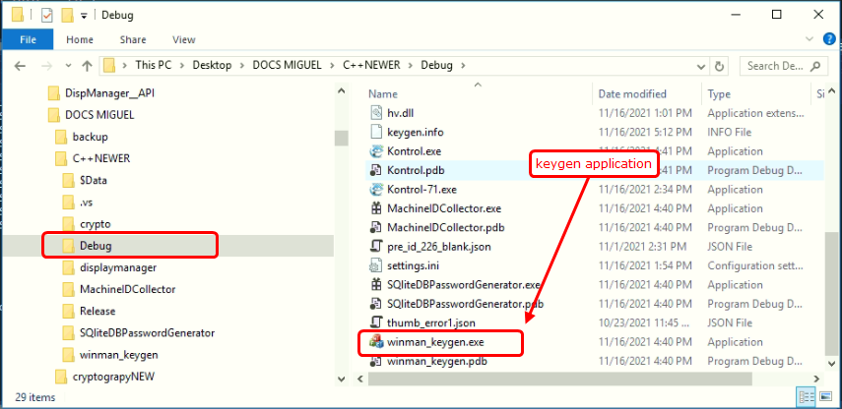

### What is flag?

When a provider generates an activation code, flag value is used.

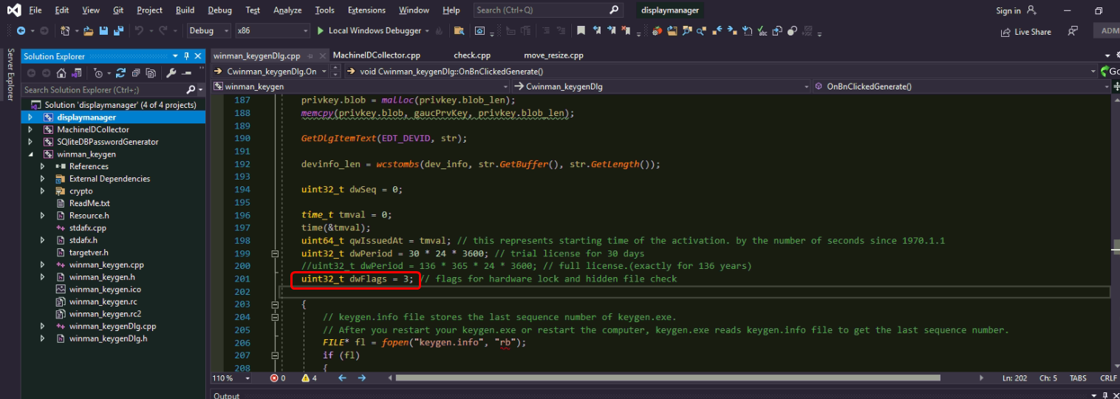

This value 3 means that this activation code is for “Kontrol”. In other words, it is the type of software which requires license. 3 means “Kontrol”.

Our cpp app(Kontrol) checks this flag value from activation code and if it is not 3, cpp app fails to run.

In displaymanager project, there is a file named “flags.cpp” in license folder.

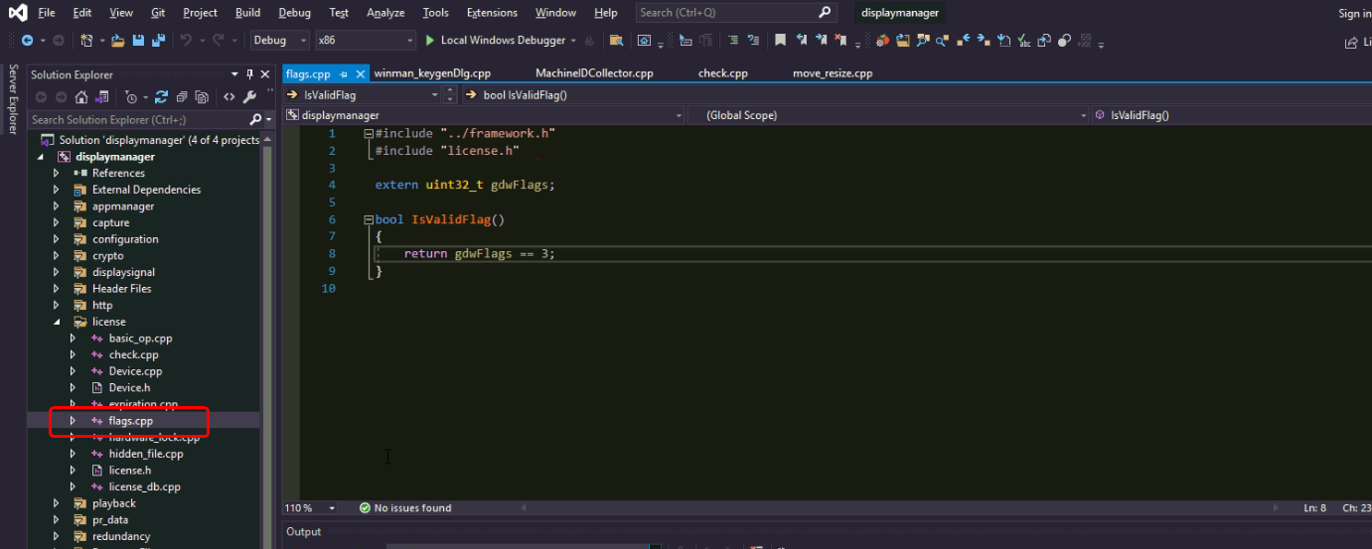

IsValidFlag() function checks the flag value of activation code.

“gdwFlags” is a global variable which is gotten from a valid activation code.

If it is not 3, cpp app considers the activation code is not valid.

So if you want to change flag value, for example to 101, then you should change the value in “winman_keygenDlg.cpp” file of “winman_keygen” project like

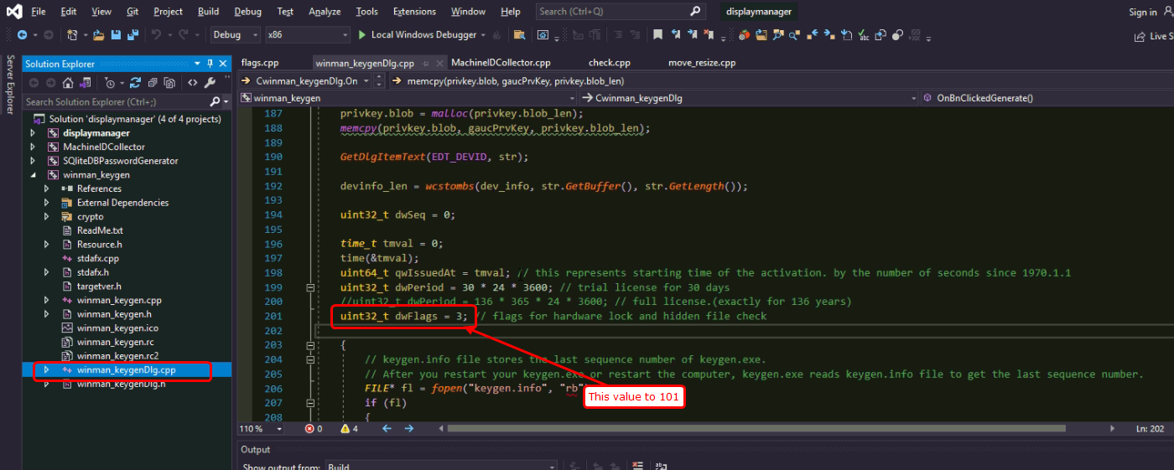

And in “flags.cpp” of “displaymanager” project like

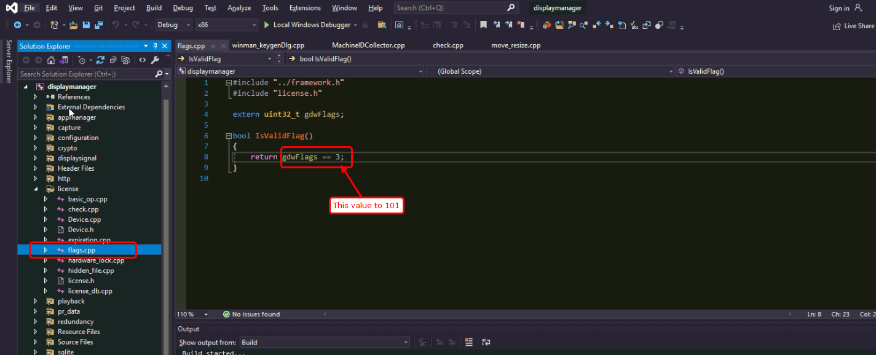

And build both projects at a time.

Cpp app (Kontrol) will run with flag value 101 by the activation code generated by newly built keygen app because newly built keygen app will use flag vaule 101.

## sqlite db management

In Cpp app, licensing data are stored in sqlite database file with password.

“license_db.cpp” in “license” folder contains several functions to handle data in sqlite db.

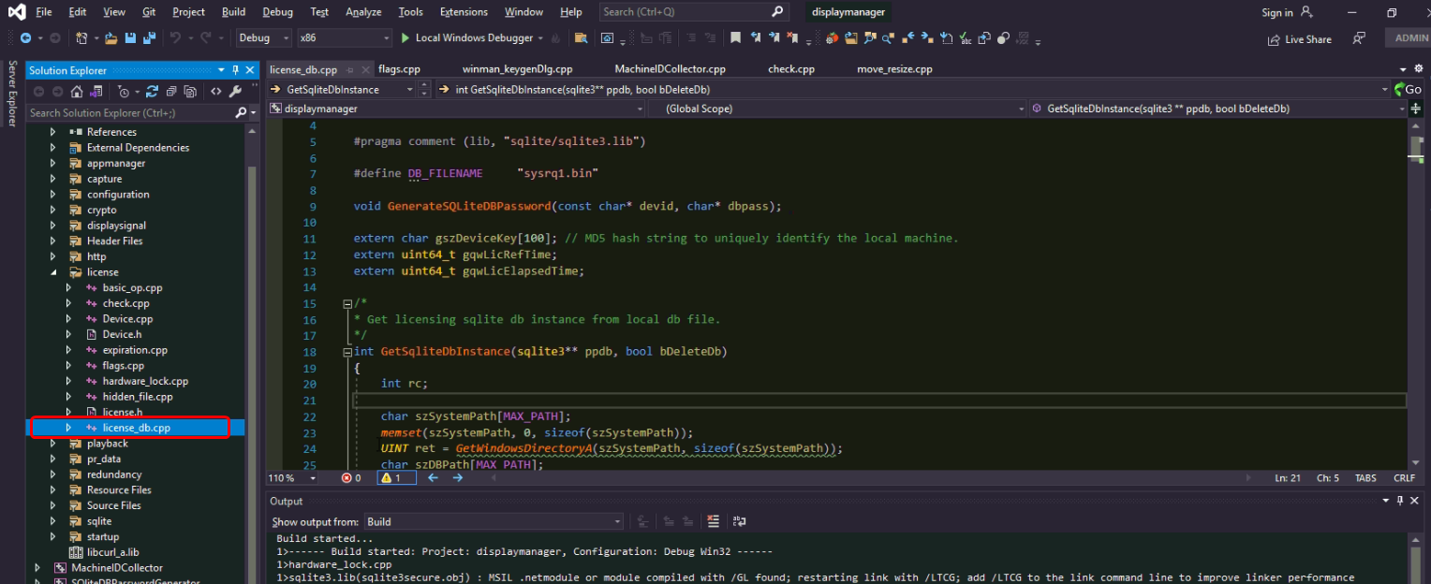

Let’s consider some issues here.

### How to change the sqlite db file path and name?

In license_db.cpp, there is a function named “GetSqliteDbInstance”.

This function handles the sqlite db file.

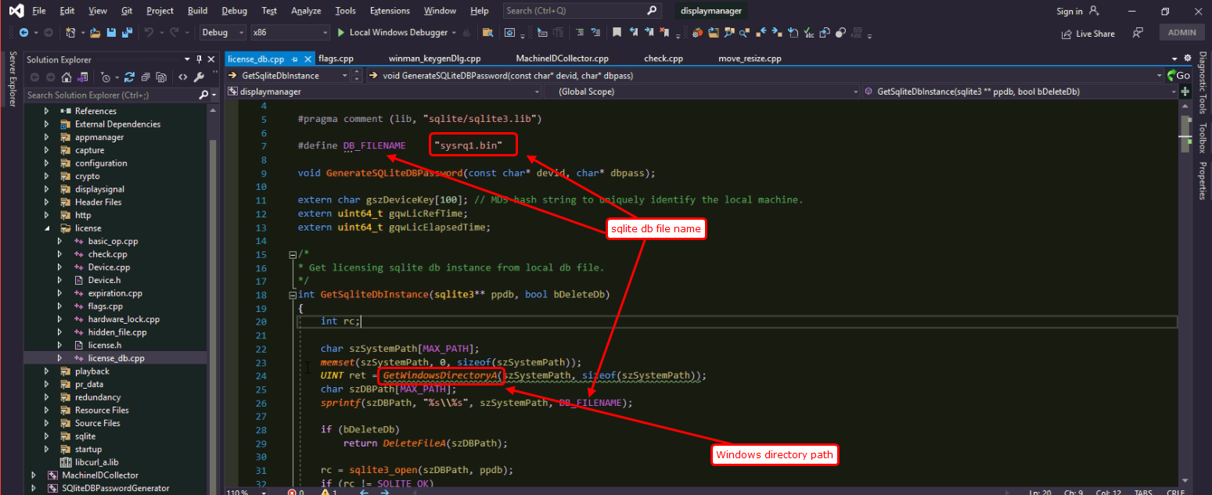

Now in this function sqlite db file is created at “C:\Windows\sysrq1.bin”.

If you want to change the sqlite db file path,

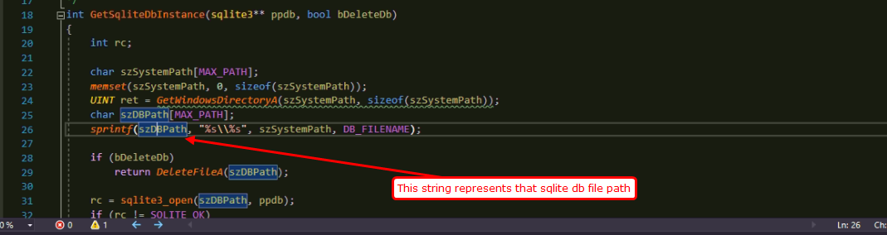

In GetSqliteDbInstance function, change the variable szDBPath.

For example, if you want to create sqlite db file at D:\HiddenPath\r1.bin, then please change the code like

|  |
| --- |
| sprint(szDBPath, “D:\\HiddenPath\\r1.bin”); |

Then sqlite db file will be created at that location.

### How to make sqlite db file without password

In GetSqliteDbInstance function, you will see the code lines like

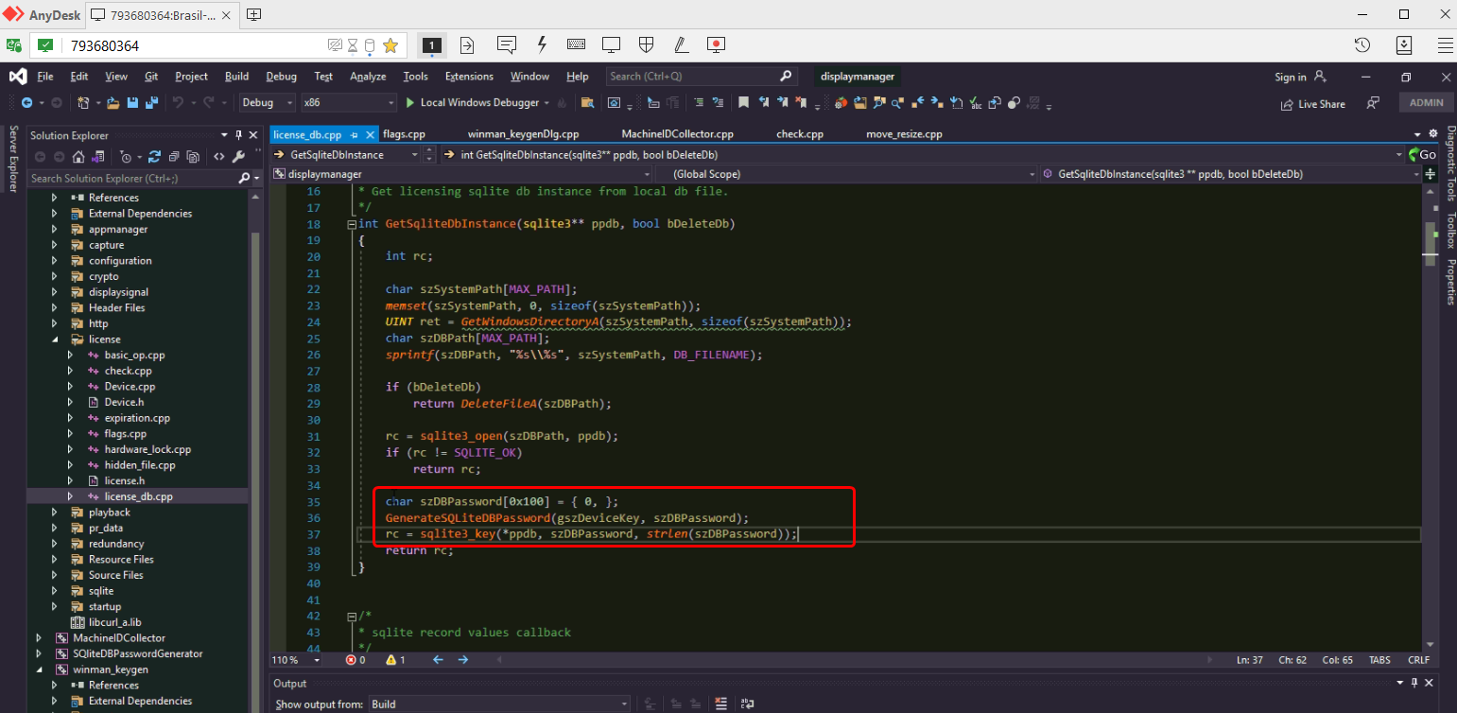

“sqlite3_key” function sets the encryption to sqlite db file by the password.

So if you want to make sqlite db file without password, please remove these 3 lines.

### How to open sqlite db file with password

By default, sqlite db file is created with password.

Its encryption method is set by sqlite library which is linked to cpp app project.

Because we built sqlite library in Release_AES128, sqlite db file will be encrypted by AES128 algorithm.



(See section” Sqlite library with encryption”)

In “displaymanager” project, “license_db.cpp” file contains GetSqliteDbInstance() function.

Please look at the function codes.



You can see it calls “GenerateSQLiteDBPassword” function.

This function makes sqlite db file password based on device id string.

So we made a tool to know the password string.

“SQliteDBPasswordGenerator” project is the one for tool.

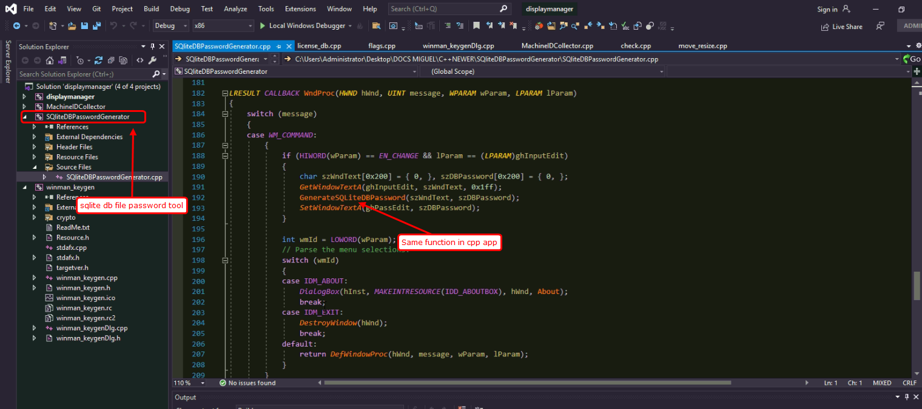

This tool generates the password of sqlite db file.

Please run this tool by pressing F5 key or double-click SQLiteDBPasswordGenerator.exe in Debug/Release folder.

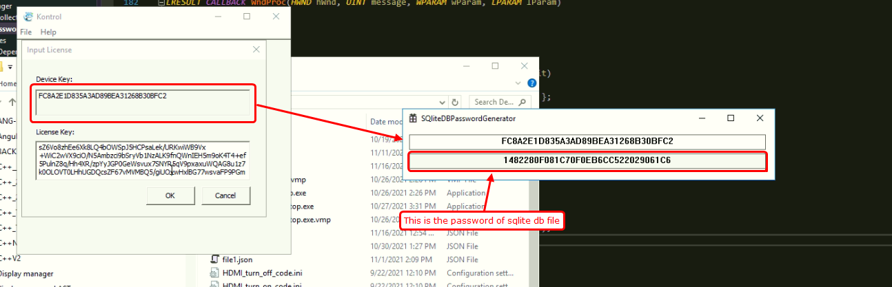

Don’t forget. This is the password for sqlite db file which was created by cpp app that has the device id string.

To view the content of sqlite db file, we use SQLiteStudio.

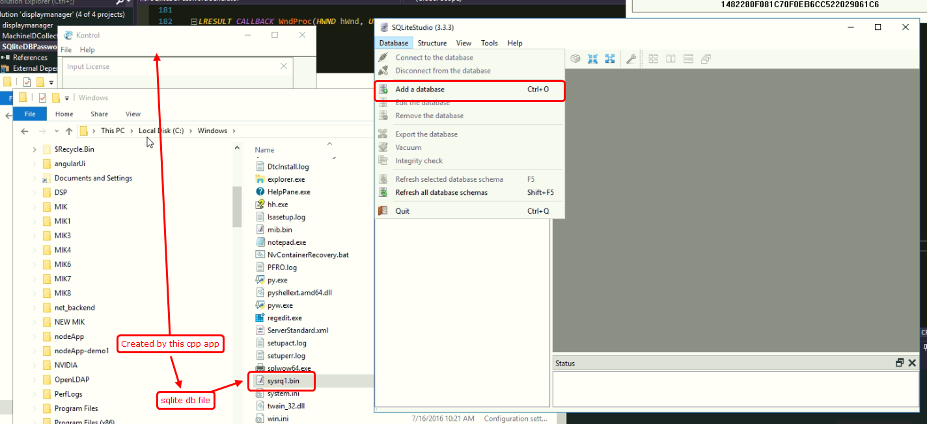

To add a database, select WxSQLite3.

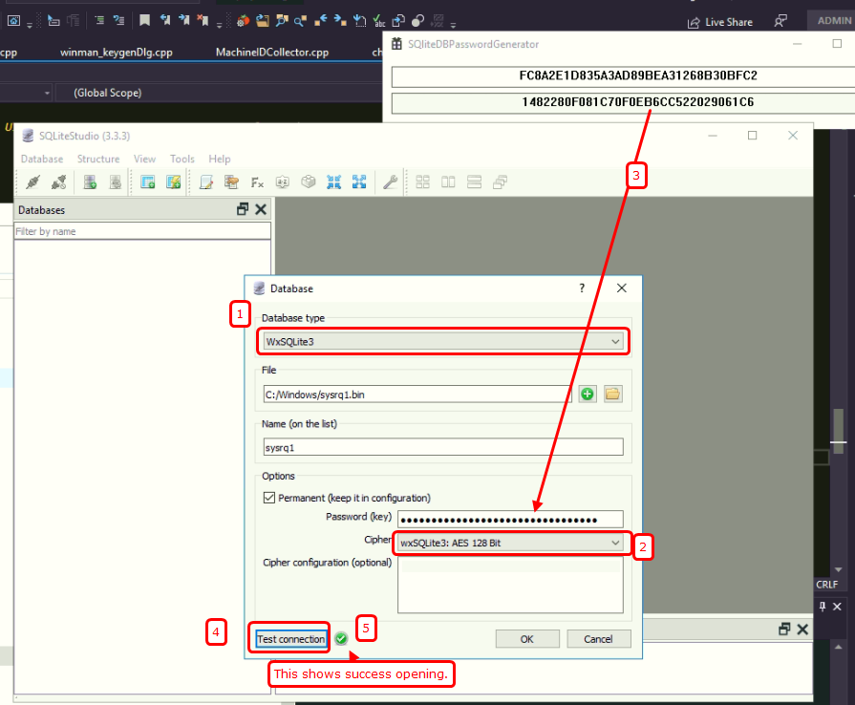

The result is open in the tool like

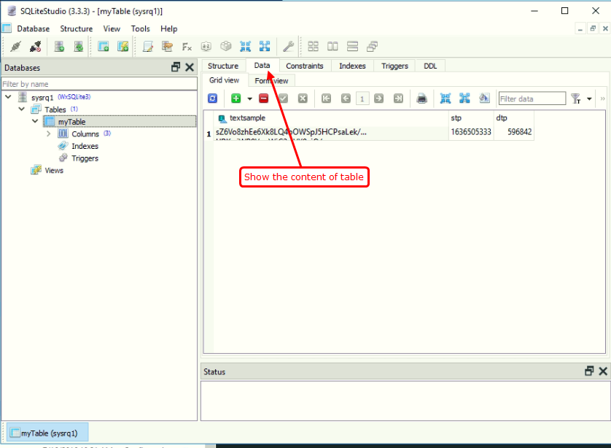

## Periodic check

Cpp app checks the validity of license periodically.

It exactly checks the validity of activation code, expiration of license, hidden file check, hardware lock check every 10 seconds.

“displaymanager” project => playback folder => main_process.cpp file has MainThread() function.

This function is the thread function for this application.

This function does periodic check of license.

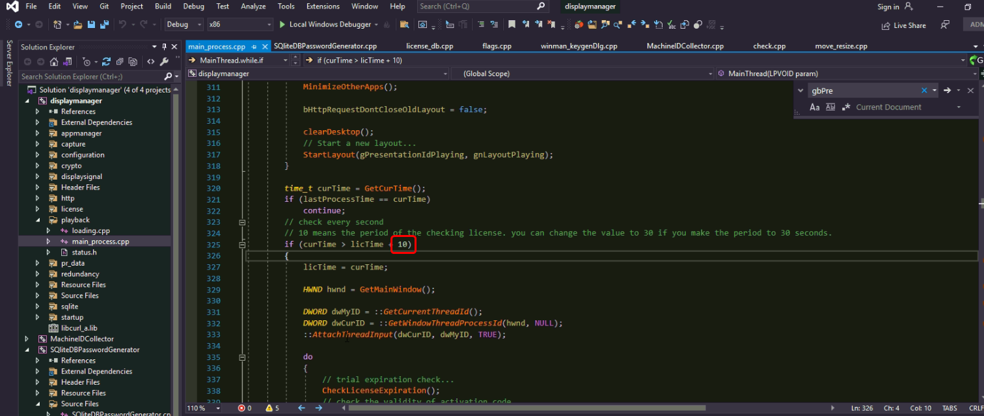

You can see the code line like above.

If you want to change to period, please change the number. This number is the amount of seconds.

If you change the number to 30, then cpp app will check the validity of the license every 30 seconds.

## Hardware lock check

“displaymanager” project => license folder => hardware_lock.cpp file has a function named “CheckHardwareLock”.

This function returns true if the hardware lock is true.

Here calls the function GetDeviceHashString which has 5 parameters.

About GetDeviceHashString, I mentioned at “Hash” section.

Here we don’t explain about the GetDeviceHashString.

You can change the parameter values with the parameters which you want.

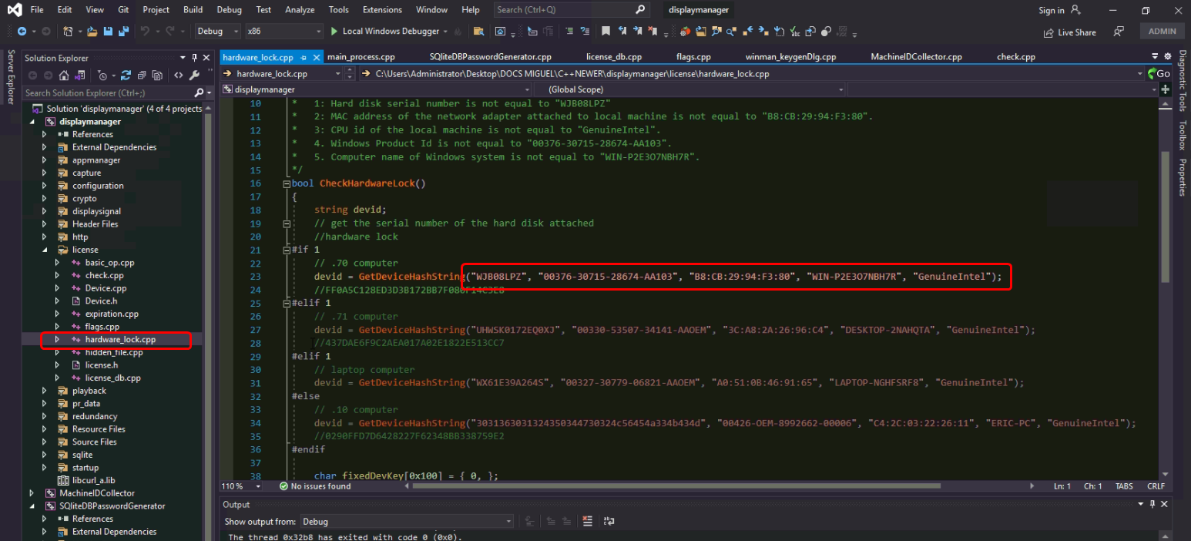

To get the hardware information of the computer, please run MachineIDCollector.

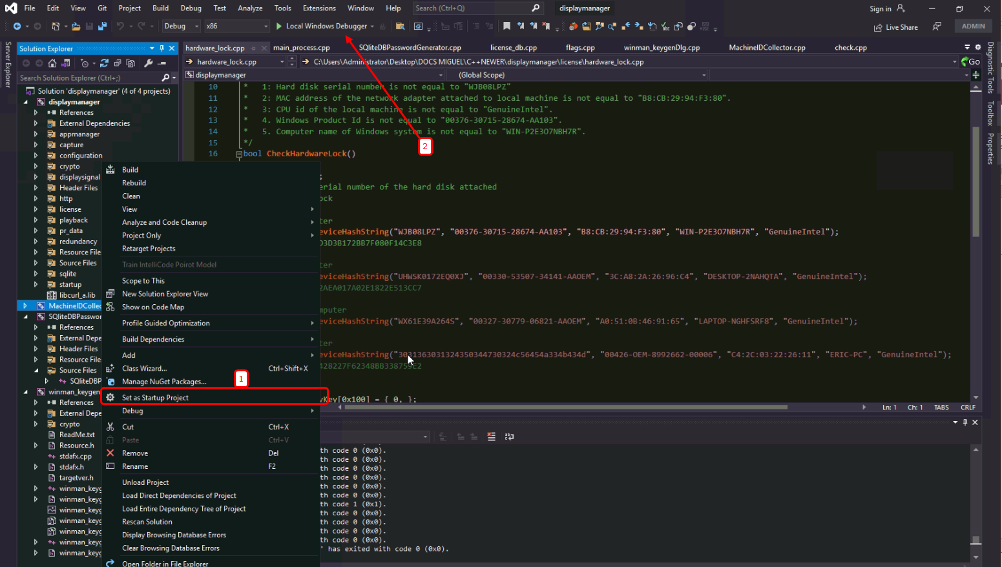

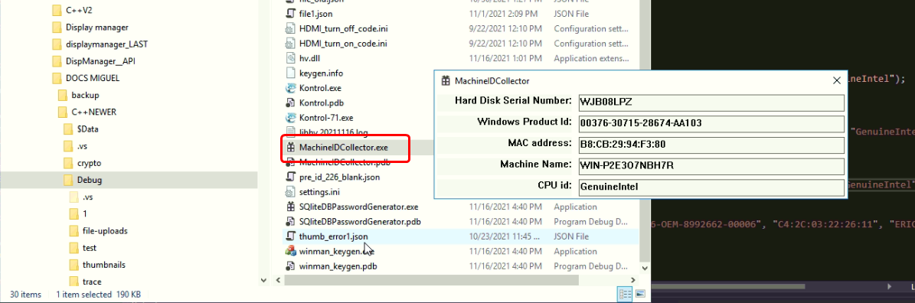

You can replace the parameters of GetDeviceHashString in CheckHardwareLock().

But as mentioned at “Hash” section, mac address and computer name don’t take part in calculation of device hash string.

## Hidden file check

Cpp app also checks the hidden file.

It first checks if the hidden file exists in the supposed path.

If it exists, cpp app checks if content is the valid activation code.

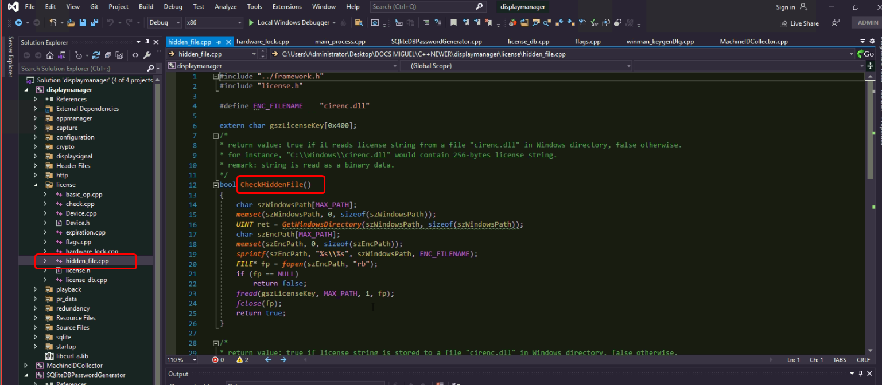

### How to change the hidden file name?

Hidden file is located in Windows folder.

The name is defined as a macro in hidden_file.cpp.

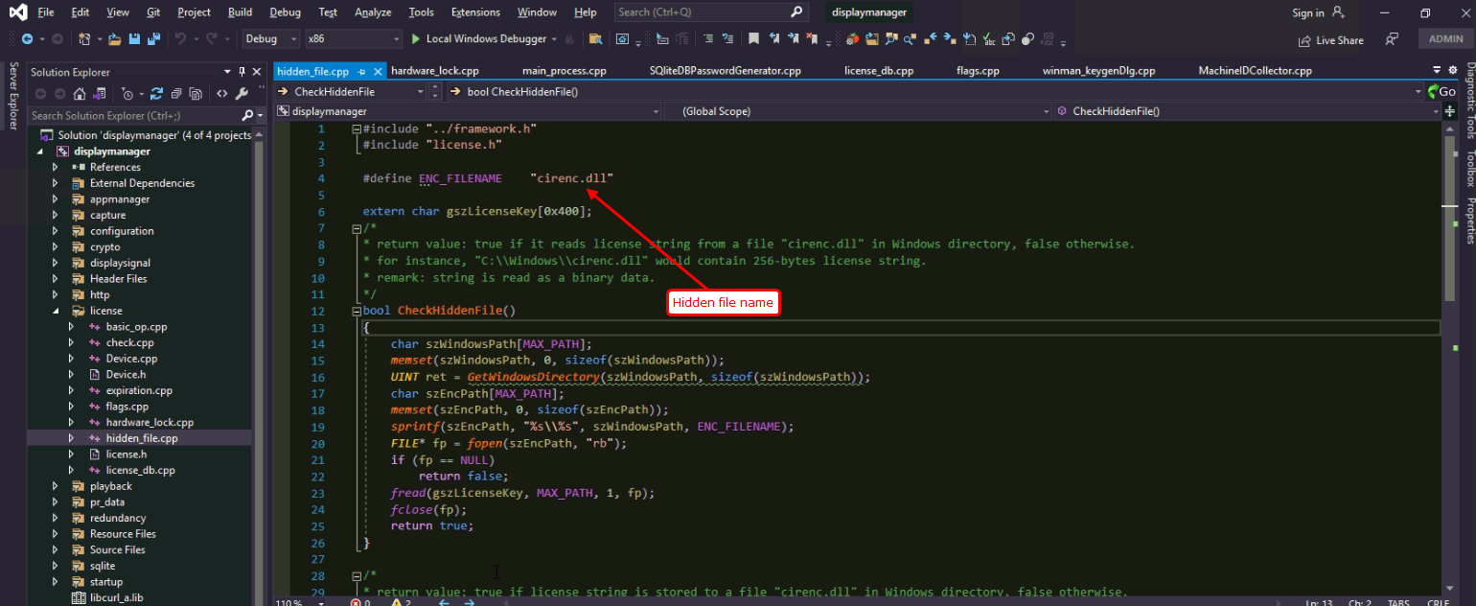

If you want to change the name of a hidden file, please replace the string with what you want.

Then hidden file will be C:\Windows\<YourHiddenFile>.

# web commands

All http commands are processed in “http_handler.cpp” file of “displaymanager” project.

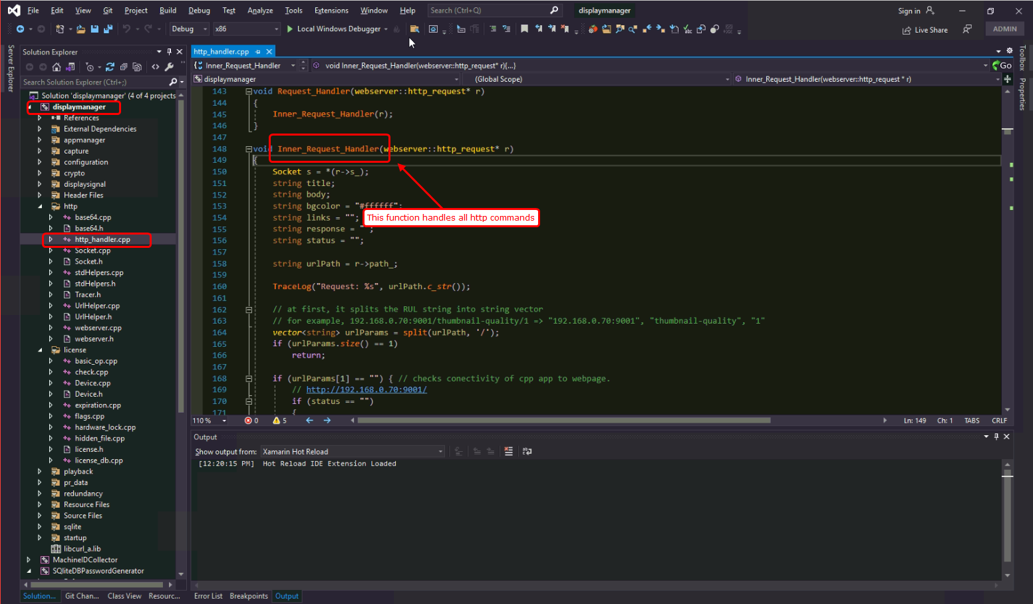

Inner_Request_Handler() function processes all http commands from angular webpage.

At first cpp app splits the URL string by ‘/’ character.

For example, 192.168.0.70:9001/play-layout/223/1/admin/ will be split into “192.168.0.70:9001”, “play-layout”, “223”, “1”, “admin”, “”

## Connection

URL is like

|  |
| --- |
| http://192.168.0.70:9001/ |

This command is not used now.

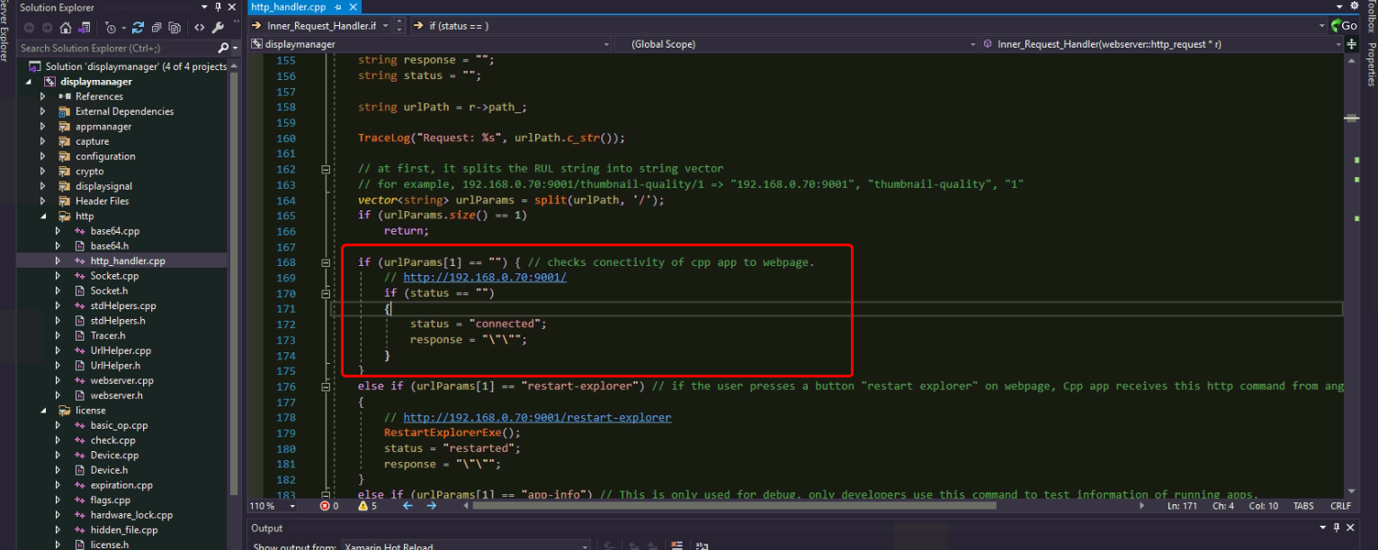

Cpp app uses ping instead.

## Ping

|  |
| --- |
| http://192.168.0.70:9001/ping |

Ping is very important http command. Webpage can get the existence of cpp app running by this http command.

And cpp app replies ping command by all running information of the layout.

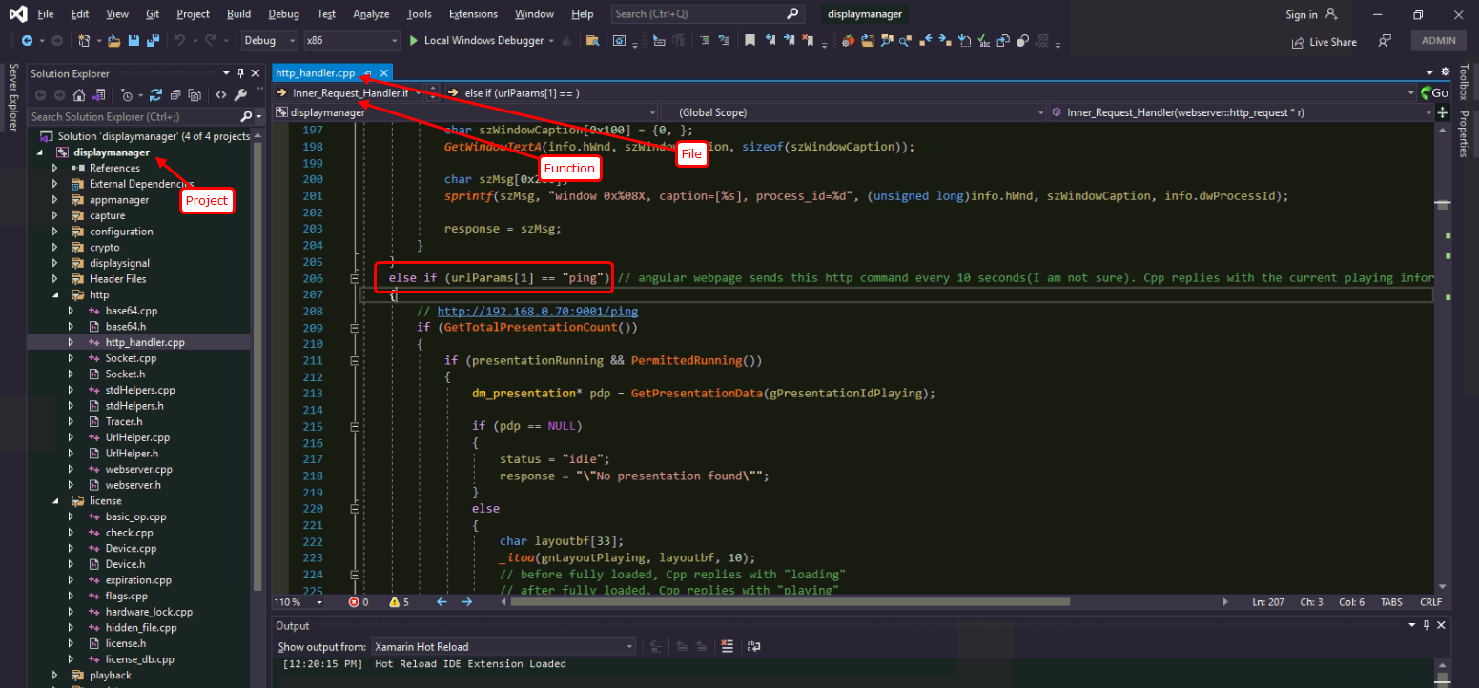

If count of total presentations is zero, it returns “idle”.

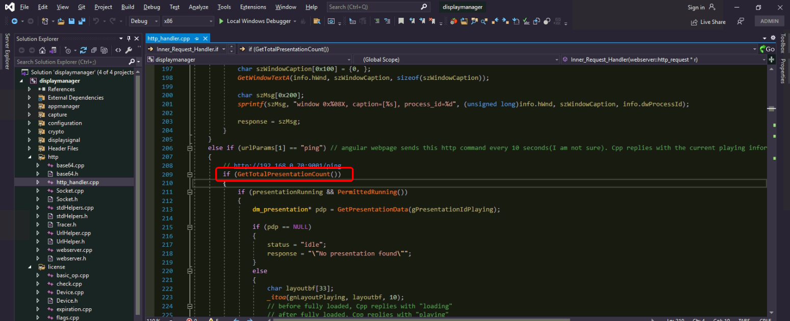

### When is total count of presentations zero?

When you want to clean all running environment and start from empty data, then you delete file.json and run cpp app.

Cpp app loads file.json content at its startup so it will load nothing.

The total count of presentations is zero.

But to play a presentation on webpage, it should publish a presentation first and count of presentations becomes at least 1. So this case only happens on error.

To prevent errors while replying ping command, this relation is needed.

### When is active ping-reply information delivered to webpage?

As mentioned above, total count of presentations should not be zero.

And active ping-reply information could be delivered when it is playing a presentation with master right.

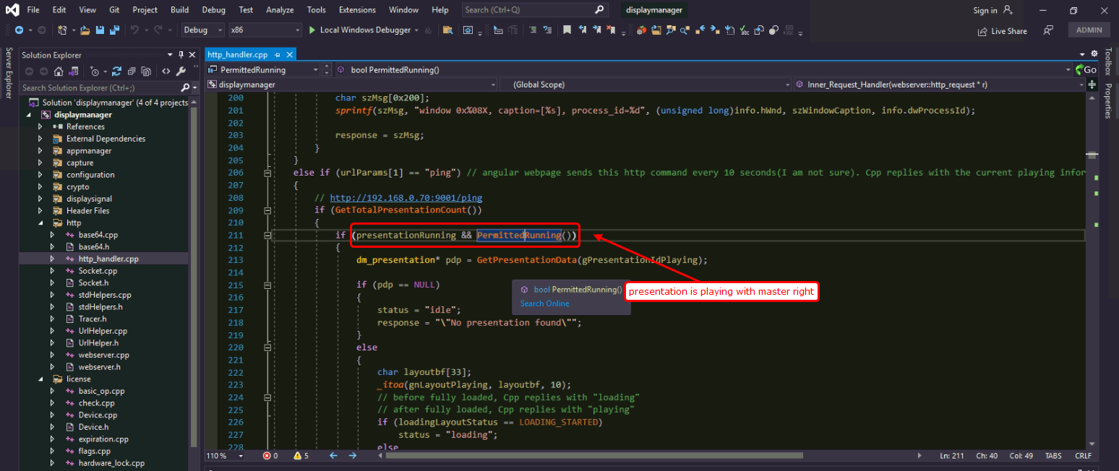

When any kind of error such as presentation data loading error happens, it will not send active ping-reply command to the webpage.

### When is reply status “loading” or “playing”?

When Cpp app receives ping command while it is loading a layout and not fully loaded, it replies with “loading” instead of “playing”.

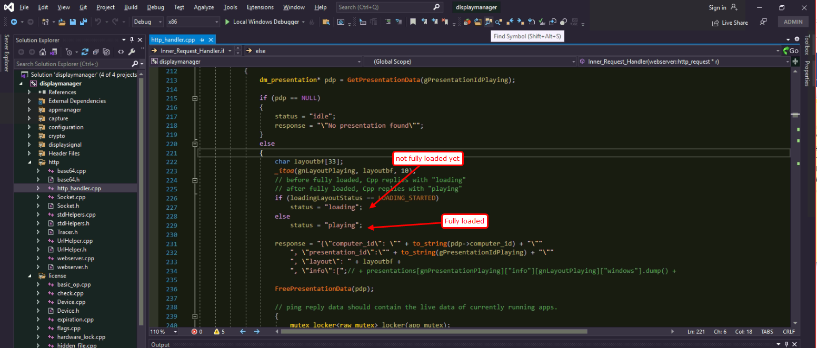

As you can see, loadingLayoutStatus variable shows the status of loading layout.

Before loading all channel windows, it is set to “LOADING_STARTED”.

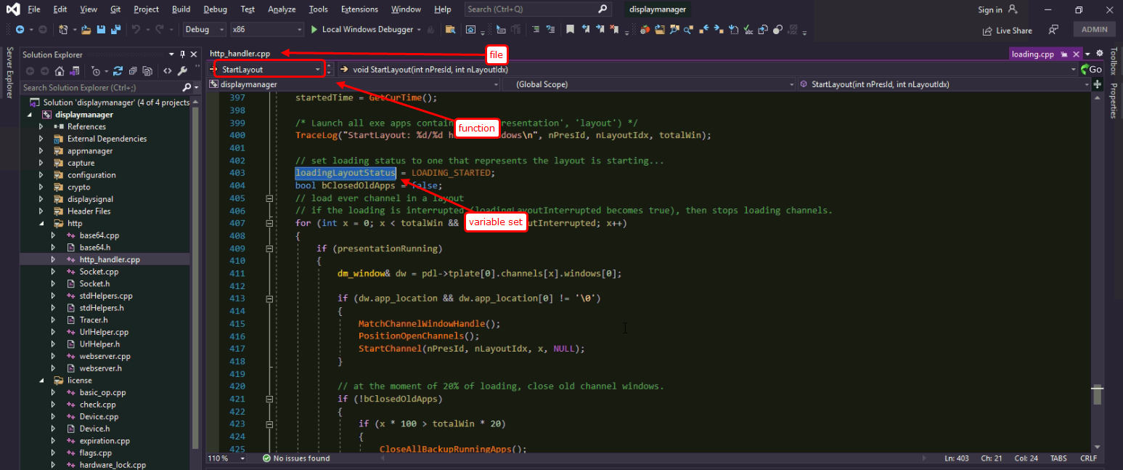

After fully loaded all channel windows, it is set to “LOADING_FINISHED”.

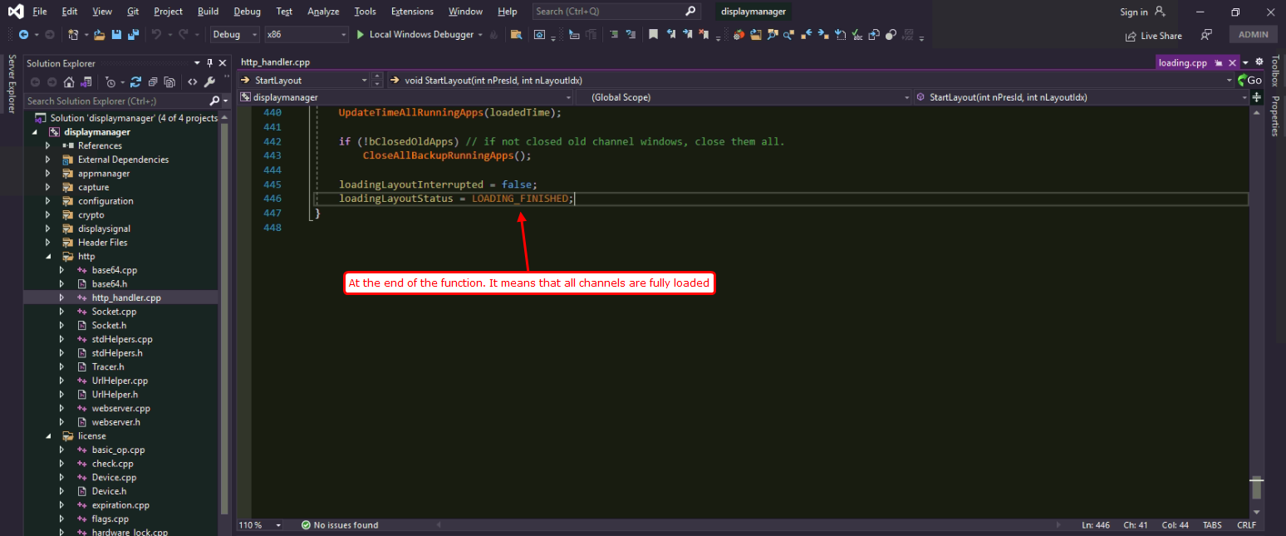

http command, and playing a presentation proceed concurrently(multithreading).

So we have to introduce some specific synchronization mechanism here.

Cpp app solved this issue by loadingLayoutStatus variable.

When cpp app receives “ping” command and loadingLayoutStatus is “LOADING_STARTED”, it replies with “loading” and when loadingLayoutStatus is “LOADING_FINISHED”, it replies with “playing”.

### Cpp app replies “ping” command by active running information. What is active running information?

Webpage configures presentation data and publishes it to cpp app.

But as related to closing some channels or move/resize action, its geometry changes by time and even some channels could be deleted.

So cpp app replies with information of only running channels(not closed ones).

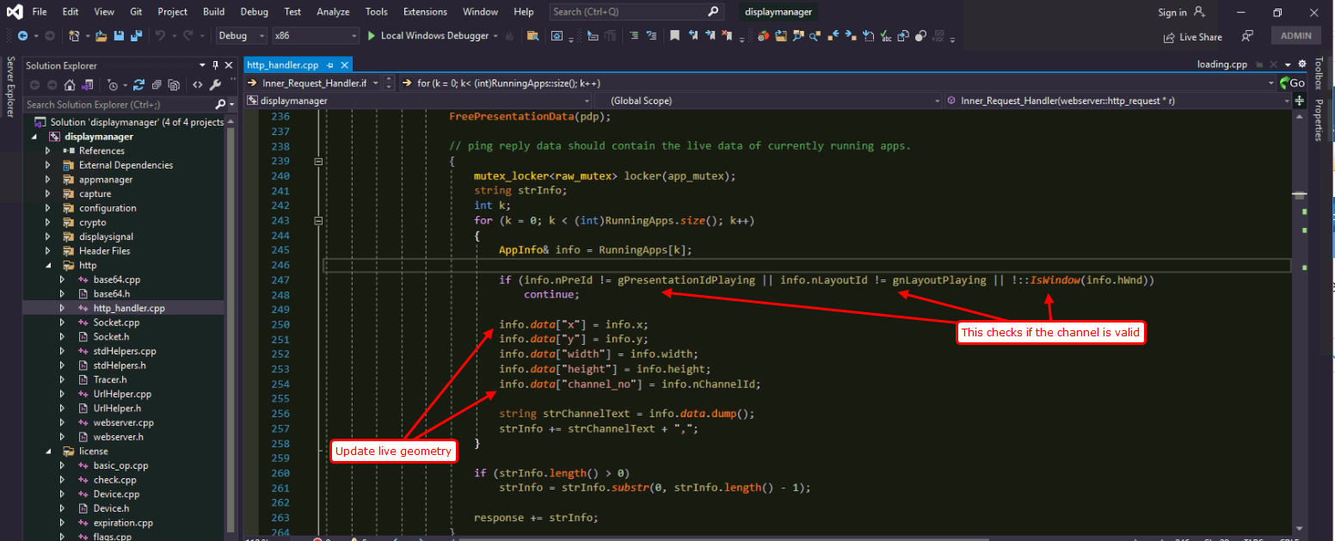

Originally configured presentation data is attached to at the starting channels.

But at the moment of receiving ping command, it updates information with live geometry.

Ping-reply text will contain live geometry of all running channels.

### Is there a way to check ping-reply text in cpp app?

After making ping-reply text, we rarely have to check its validity of json format.

So I added some code for it and now disabled it.

If you enable the checking part, when an error happens, you will see “ping_error.json” file created in the cpp app folder.

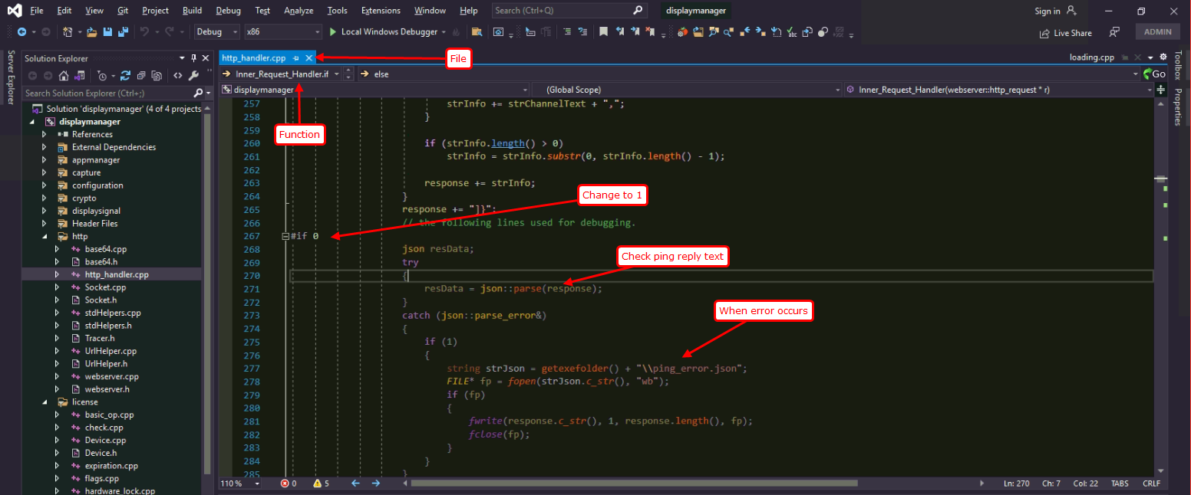

Please make the code line to

|  |
| --- |
| #if 1 |

After you checking ping-reply text, please make it to original one.

|  |
| --- |
| #if 0 |

## Play/Play-layout

|  |
| --- |
| http://192.168.0.70:9001/play/presentation_id/layout_index/owner |
| http://192.168.0.70:9001/play-layout/presentation_id/layout_index/owner |

“play” http command is similar to “play-layout” command.

Cpp app does not use “play” command.

When a user presses “Play Layout 1”, then cpp app receives “play-layout” command.

So here we explain about “play-layout”.

This http command only works if the presentation exists (published already), and cpp app works as a master.

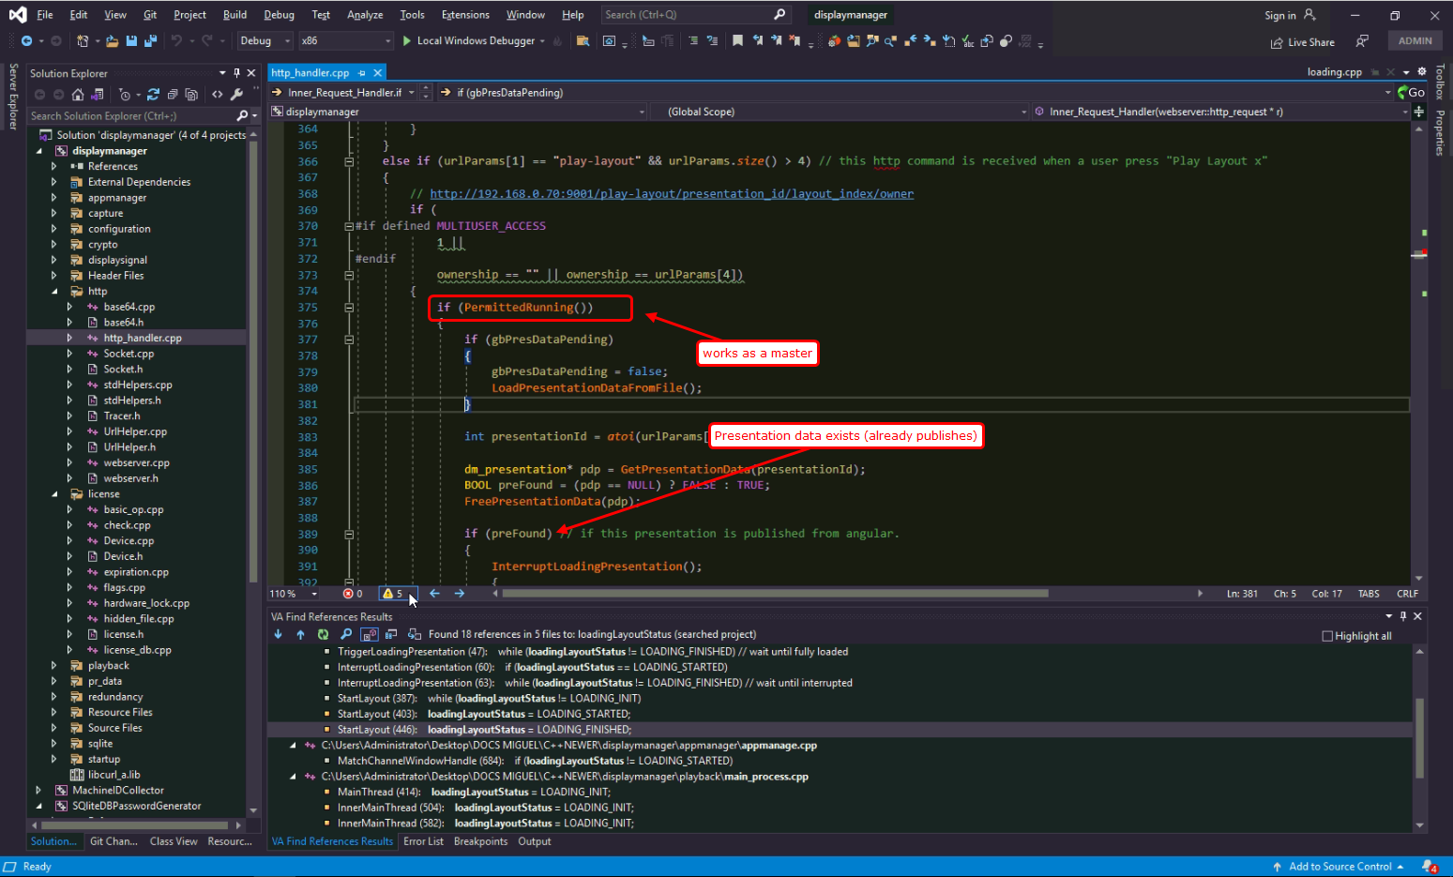

Here the remarkable part is loading presentation data if pending.

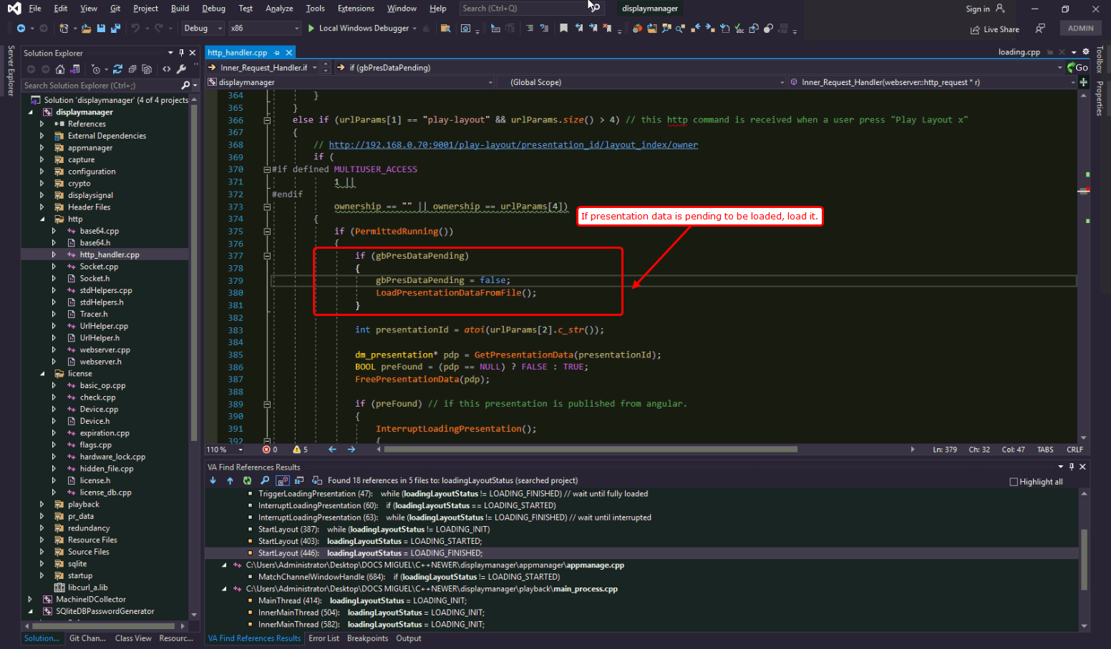

For further information, please see “Unpublish” or “Get-presentation section”.

At first, cpp app checks if the presentation exists in presentation data.

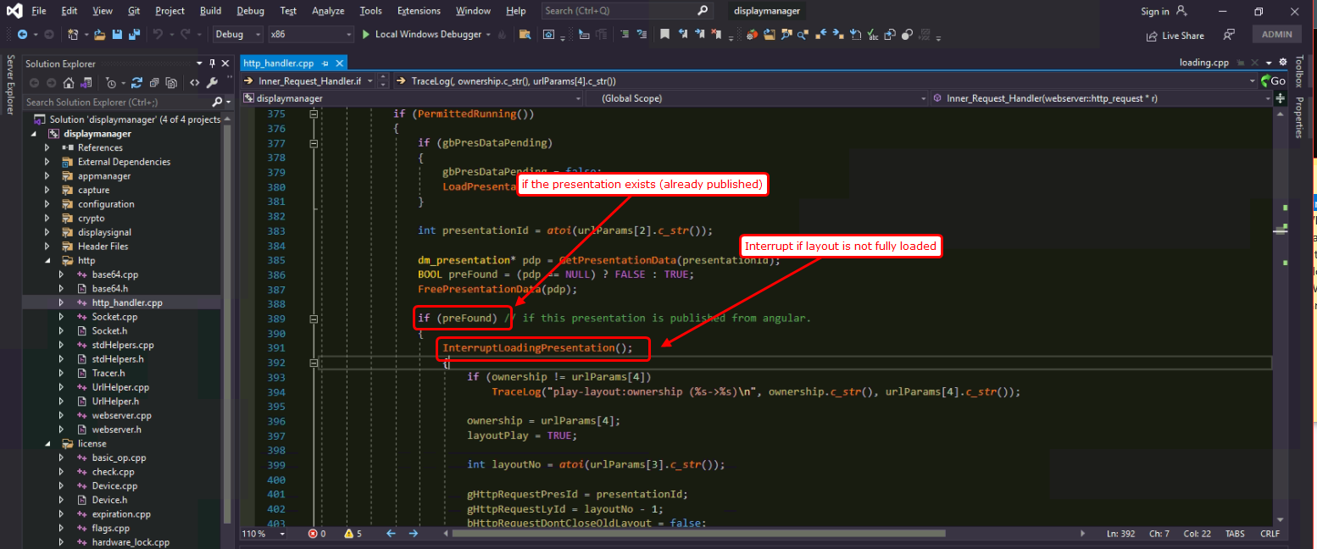

## Unpublish

## Schedule

It is not used in this project.

It is made by old dev, but we do not use it here.

## File-upload

On file-upload, there is a problem while processing URL strings.

For example, if the file name is “不 tt.mp4”, angular send the URL to cpp app like

|  |
| --- |
| %E4%B8%8D%20tt.mp4 |

URL string translates real string to ASCII-readable string. Webpage engine(javascript) translates all Non-ASCII characters(such as Chinese characters, Portuguese characters, …) to %xx format and non-printable ASCII characters to %xx format.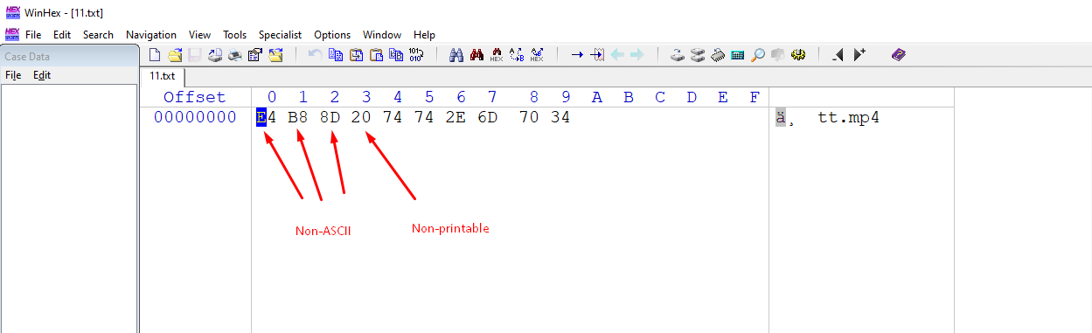

So cpp app receives “%E4%B8%8D%20tt.mp4” from webpage for “不 tt.mp4”.

Cpp app should interpret the URL string to real one.

Now Eric did not agree to interpret all the non-ASCII characters so that cpp app is now interpreting only ‘%20’ character to ‘ ’.

Cpp app will work in case of “ATT%20see.mov” to “ATT see.mov”.

But will not work in case of “%E4%B8%8D%20tt.mp4” because cpp app has no interpretation engine for non-ASCII characters.

I did interpretation for non-ASCII characters, but he disliked so I removed again… pity.

Exact code part here (screenshot)

### What is the solution for file name to upload?

So the solution for this problem now is to upload files of name with only ASCII-characters + space character.

The available file name includes

|  |
| --- |
| English lower/upper case characters |
| Digits |
| ~`!@#$%^&()=+-_ |

## get-presentation

this http command is dispatched to cpp app from angular webpage when a user “publish”es a presentation on webpage.

At first angular webpage sends cpp app the URL only which contains the presentation id.

### What are “publish” steps between angular and cpp app?

This has the most complex steps in this cpp project.

First, a user presses “publish” button on webpage.

Second, webpage sends <http://192.168.0.70:9001/get-presentation/225> to cpp app. Here port number 9001 is hardcoded in cpp code and angular code.

Third, cpp app interprets the URL and get the presentation number from it. It is 225 here. And it sends the data request to a webserver by curl.

webserver URL is configured in settings.ini.

For example, 192.168.0.71:5010.

Pay attention to a webserver. It is not angular webpage. It is a .net server.

Fourth, .net server transmits presentation data on curl requested by cpp app.

Fifth, cpp app receives presentation data from a webserver by curl.

After receiving presentation data from a .net server, cpp app replies to a angular webpage with “success”.

If it fails to receive from a .net server, it replies with “fail”.

Angular webpage

Cpp app

Webserver

.net

get-presentation

Request by curl

Response by curl

success

port 9001

port 9001

settings.ini

## View-control

This http command is received when a user presses a button on angular webpage “live-feed”, or “kontrol”.

When this command is received, cpp app brings the app selected on top of other apps.

## Section-control

This category has 4 http commands “max”, “def”, “close”, “app/flag”.

This http command is received when a user presses a button on angular webpage “live-feed”, or “kontrol”.

## Stop-presentation

## Close-app

## Restart-explorer

## Shutdown

## Get-device-info

## sendEvent

## sendNotice

## thumbnail-quality

## picture/1

# Synchronization of presentation data

## Retrieval from webserver

## Saving on local storage

## Interacting with playing presentation

# Playing/stopping layouts

## Play presentation

### Webpage command

### Sequencer automation

### Scheduler automation

## Play layout

### Rewinding

### Overlay of layouts

## Play channel

### Launching an external app

### Recovering app window handle

## Stopping presentation

## Closing a specified window.

# Move/resize by web users

## Creation of a websocket server

## move/resize command process thread

# Thumbnails for web users

## Creation of a websocket server

## Capturing thumbnail images

## Thumbnail quality

# Basic features for running application windows

## Location of window geometry

## Slicing window

## Full-screen/maximize

## Replacing app window

# Redundancy

## Algorithm

## Creation

## switchover

# RS232 commands for signal input

## Command file format

## Transmit command to RS232

# Log

## Log file path

## Logging

# Startup windows OS.

## Registry setting

## Launching presentation at start up of windows OS.

# Splash screen

# Additional FAQs:

## How can we check the TCP connection is normal or broken?

You can check it by wireshark.

<https://www.wireshark.org/download.html>

After installing wireshark for windows, please run it.

Select correct NIC and double click it.

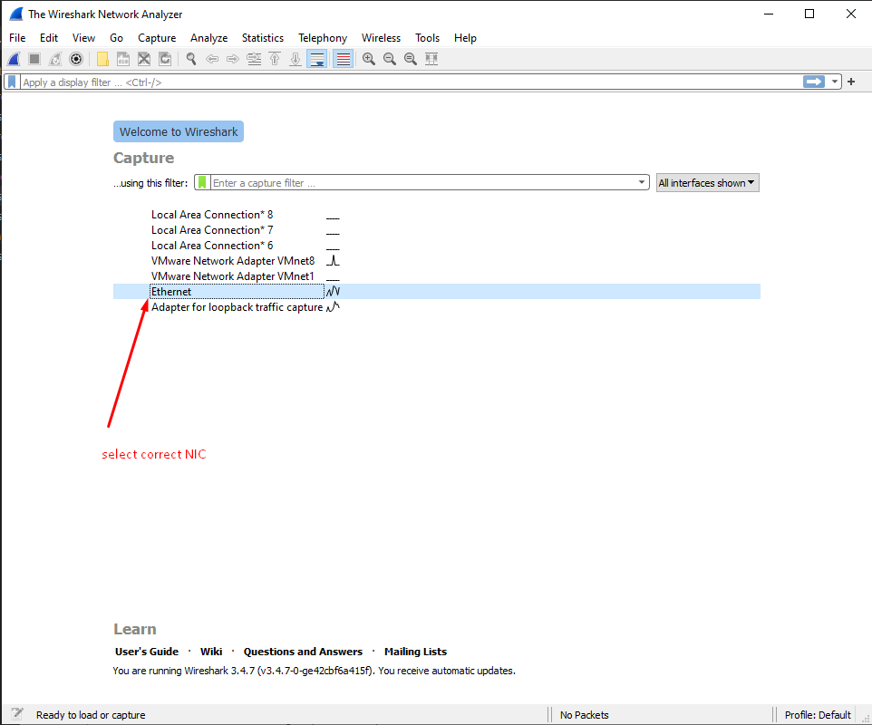

Let’s assume that a user runs angular webpage at 192.168.0.71 and cpp app runs at 192.168.0.70.

Angular webpage sends http commands by port 9001. So we can check it by filtering tcp.port == 9001

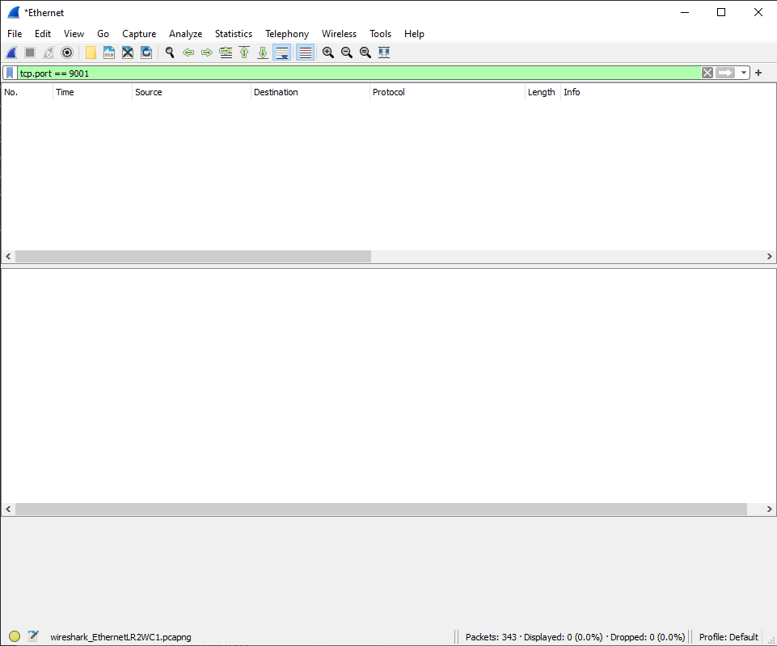

If you can see any packets there and source IP, destination IP are the ones of cpp app and angular webpage, TCP connection is working.

Let’s assume that you configured move/resize+KVM port 6001, and thumbnail port 6002.

To check the port 6001, or 6002, you can input in filter box

|  |
| --- |
| tcp.port == 6001 |
| tcp.port == 6002 |
| … |

You can check source IP, and destination IP for your cpp app and .net app or angular webpage.

If nothing shows, the connection is not existing.

So you should check the connection state by “ping” command.

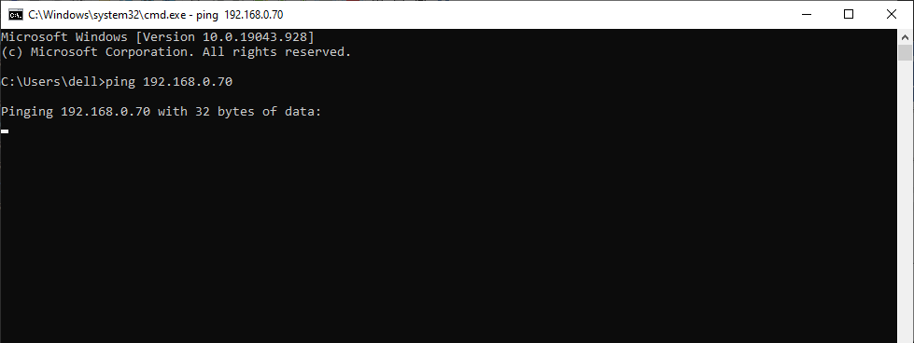

If “ping” works good, you should check settings.ini and webpage working.

In our cpp project, there are 4 types of TCP ports and 1 UDP port.

|  |  |  |  |
| --- | --- | --- | --- |
| Connection | Port | Mission | Modification |
| TCP | 9001 | Angular webpage | Can not modify |
| TCP | 6001 | Move/resize + KVM websocket | Configured in settings.ini |
| TCP | 6002 | Thumbnail websocket | Configured in settings.ini |
| TCP | 5010 | .net webserver for presentation data request | Configured in settings.ini |
| UDP | 54332 | Redundancy UDP communication | Written in CMateComm.cpp |

To check the UDP port, input in filter box like

|  |
| --- |
| udp.port == 34221 |

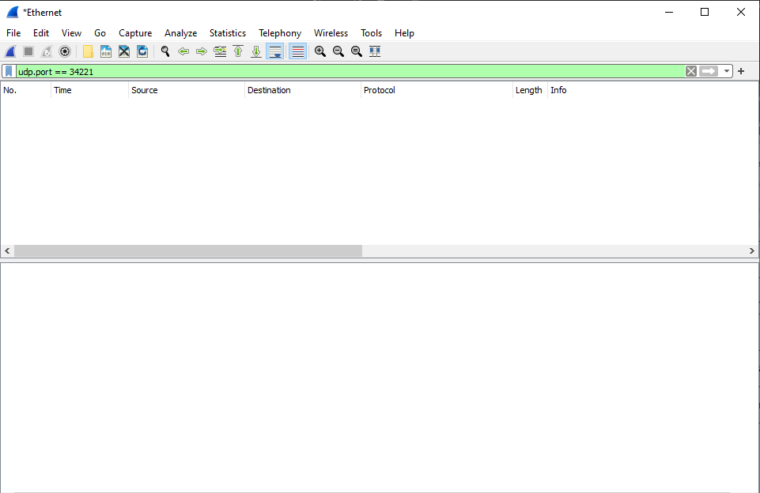

Also here, if some packets are shown, it works good. But don’t forget to check the source IP and destination IP.

If nothing is shown, no communication is working here.